Data Capture Specifications for Road Net Elements
Ontario Road Network
Guide to Best Practices for Acquisition
  - Geospatial Services
  - Digital, Data, Information and Business Services Branch
  - Corporate Management and Information Division
  - Ministry of Natural Resources
2025-04-23

Disclaimer
This technical documentation has been prepared by His Majesty the King in right of Ontario as represented by the Ministry of Natural Resources (the “Ministry”). No warranties or representations, express or implied, statutory or otherwise shall apply or are being made by the Ministry with respect to the documentation, its accuracy or its completeness. In no event will the Ministry be liable or responsible for any lost profits, loss of revenue or earnings, claims by third parties or for any economic, indirect, special, incidental, consequential or exemplary damage resulting from any errors, inaccuracies or omissions in this documentation; and in no event will the Ministry’s liability for any such errors, inaccuracies or omissions on any particular claim, proceeding or action, exceed the actual consideration paid by the claimant involved to the Ministry for the materials to which this instructional documentation relates. Save and except for the liability expressly provided for above, the Ministry shall have no obligation, duty or liability whatsoever in contract, tort or otherwise, including any liability or negligence. The limitations, exclusions and disclaimers expressed above shall apply irrespective of the nature of any cause of action, demand or action, including but not limited to breach of contract, negligence, strict liability, tort or any other legal theory, and shall survive any fundamental breach or breaches.
Cette publication spécialisée n’est disponible qu’en anglais.

Additional Information
This document does not comply with all the applicable guidelines for accessible digital documents. For an alternative format please email Geospatial Services at geospatial@ontario.ca.
For more information about this document, please contact Geospatial Services at geospatial@ontario.ca.

Document History
Version | Date | Description
0.1 | 2018-06-01 | First draft, Initial review by ORN team members.
0.2 | 2018-06-29 | First draft finalized.
1.0 | 2019-01-09 | Review and comments from ORN team members incorporated into body of the document. Format finalized.
1.1 | 2019-01-11 | Converted to pdf for AODA compliance.
2.0 | 2025-03-11 | Converted to new template

Executive Summary

Key Words
Ontario Road Network, ORN, Linear Referencing System

Abstract
This Guide to Best Practices for Acquisition details the data capture specifications for the ORN Road Net Element (ORNELEM) Geospatial Ontario (GEO) Data Class. With a positional accuracy of 10 metres or better the ORN is the authoritative source of roads data for Ontario. ORNELEM is a Linear Reference System (LRS) and is suitable for creating products and services including mapping, analysis and geocoding applications.
The ORN is a Government of Ontario Information Technology Standard (GO-ITS 29). Refer to Links to Additional Information for more information.

Table of Contents
Disclaimer 2
Additional Information 2
Document History 3
Executive Summary 4
Key Words 4
Abstract 4
Table of Contents 5
List of Figures 9
List of Tables 16
List of Acronyms 17
1. Overview 18
2. Data Quality 19
2.1 Core Content 19
2.2 Geometry – Positional Accuracy 20
2.3 Attribute – Thematic Accuracy 20
2.4 Temporal Accuracy 20
2.5 Topological Accuracy 20
3. Road Elements 21
3.1 Core Content 21
3.1.1 Mandatory Geometric Representation 21
3.1.2 Optional Geometric Representation 32
3.1.3 Unauthorized Geometric Representation 35
3.2 Geometry – Positional Representation 36
3.2.1 Lower Left Rule 36
3.2.2 Road Centreline 36
3.2.3 Segmentation 39
3.2.4 Cul-de-Sac 41
3.2.5 Divided Carriageways, Lanes and Ramps (Median Strips) 43
3.2.6 Slip Lanes (Turning Lanes) 49
3.2.7 Passing Lanes for Through Traffic 51
3.2.8 Roundabouts (Traffic / Turning Circles) 52
3.2.9 Undefined Route (Winter Roads and Ice Bridges) 53
3.2.10 Minimum Size of a Road Element (from Junction to Junction) 53
3.2.11 Roads Crossing Administrative Boundaries 54
3.3 Attributes – Thematic Representation 55
3.3.1 ORN Road Element Feature Table 55
3.3.2 Address Information 58
3.3.3 Alternate Street Name 58
3.3.4 Blocked Passage 58
3.3.5 Junction 61
3.3.6 Jurisdiction 61
3.3.7 Number of Lanes 61
3.3.8 Official Street Name 63
3.3.9 Road Class 64
3.3.10 Road Net Element Source 71
3.3.11 Road Surface 71
3.3.12 Route Name 72
3.3.13 Route Number 73
3.3.14 Speed Limit 74
3.3.15 Street Name Parsed 74
3.3.16 Structure 75
3.3.17 Toll Point 76
3.3.18 Underpass 77
3.4 Topological Representation (Topology) 81
3.4.1 Junctions 81
3.4.2 Positional Errors (Digitizing Errors) 81
3.4.3 Overlap 81
4. Ferry Connections 82
4.1 Core Content 82
4.1.1 Mandatory Geometric Representation 82
4.1.2 Unauthorized Geometric Representation 83
4.2 Positional Representation (Geometry) 83
4.2.1 Route of the Ferryboat 83
4.2.2 Ferry Route and Ice Bridges 84
4.2.3 Ferry Connection Segment Valence 84
4.3 Thematic Accuracy (Attributes) 84
4.3.1 Jurisdiction 84
4.3.2 Road Class 85
4.3.3 Road Net Element 85
4.3.4 Route Number 85
4.3.5 Route Name 85
5. Virtual Roads 86
5.1 Core Content 86
5.1.1 Mandatory Geometric Representation 86
5.1.2 Unauthorized Geometric Representation 86
5.2 Positional Representation (Geometry) 86
5.2.1 Address Anchors on Islands 87
5.2.2 Address Anchors on Walkways 87
5.3 Thematic Accuracy (Attributes) 88
5.3.1 Address Information 88
5.3.2 Jurisdiction 89
5.3.3 Official Name 89
5.3.4 Road Net Element Source 89
6. Junction 90
6.1 Core Content 90
6.1.1 Mandatory Geometric Representation 90
6.2 Positional Accuracy (Geometry) 90
6.3 Thematic Accuracy (Attributes) 91
6.3.1 Junction Type 91
6.3.2 Exit Number 94
7. Address Range 95
7.1 Core Content 95
7.1.1 Street Name 95
7.1.2 House Number 95
7.1.3 Address Range 95
7.2 Positional Accuracy 96
7.2.1 Street Name Extent 96
7.2.2 Address Range Extent 96
7.2.3 Street Name Extent 97
7.3 Thematic Accuracy 97
7.3.1 Abbreviations for Street Type 97
7.3.2 Route Names, Route Numbers as Street Names 97
8. Links to Additional Information 98
9. References 99
10. Appendix A: Merging Angles 100
11. Photo Examples 104
11.1 Blocked Passages 104
11.1.1 Examples of Permanently Fixed Blocked Passages 104
11.1.2 Example of a Removable Blocked Passage 105
11.2 Road Surface – Pavement Status 106
11.2.1 Examples of Paved Road Surfaces 106
11.2.2 Examples of Unpaved Road Surfaces 108
11.3 Structure Type 109
11.3.1 Examples of Road Structure Type 109
11.4 Underpasses 112
11.4.1 Examples of Underpass Type. 112

List of Figures
Figure 1: This single lane dirt road with an official posted street name is to be represented as part of the minimal ORN core network. 22
Figure 2: This single lane dirt road with an official posted street name is to be represented as part of the minimal ORN core network; where Functional Road Class: Local / Strata and Jurisdiction: Private. 22
Figure 3: This single lane dirt road is to be represented as part of the minimal ORN core network as it services more than one dwelling (as evidenced by the multiple family signs). 23
Figure 4: This single lane dirt road with a Primary FMP road classification is used for forestry operations and is to be represented as part of the minimal ORN core road network; where Functional Road Class: Resource / Recreation and Jurisdiction: Ministry of Natural Resources. 24
Figure 5: This service lane (highlighted) accesses the Port Hope ONroute Travel Plaza and is to be represented as part of the minimal ORN core road network; where Functional Road Class: Service (-78.431208, 43.943615 Decimal Degrees). 25
Figure 6: This emergency U-Turn uniting a divided carriageway of a Freeway is to be represented as part of the minimal ORN core road network; where Functional Road Class: Service (-78.328341, 44.270991 Decimal Degrees). 26
Figure 7: Public, non-restrictive U-Turns on Terry Fox Drive in the City of Ottawa (-75.919007, 45.349999 Decimal Degrees). 26
Figure 8: Mavis Road and Clementine Drive in the Region of Peel, symbolized by Road Class, demonstrating the practice of the assigning the attributes of the adjoining road to the short segments that unite divided carriageways (-79.749979, 43.643537 Decimal Degrees). 27
Figure 9: Ice bridge (and Ferry route in the summer) between Lefaivre, ON and Montebello, QC (-74.883275, 45.639963 Decimal Degrees). 28
Figure 10: These new roads, whose geometry was provided by a partnering municipality but cannot yet be verified using the MNR’s most recent imagery, will be incorporated into the ORN because they are named, have addressing and there are obvious signs of development. 29
Figure 11: An example of an isolated road network in the ORN in Keewaywin First Nation (-92.835591, 52.990785 Decimal Degrees). 30
Figure 12: LIBRARY LANE and SCHOLARS WALK (highlighted) are walkways with addressing incorporated as Road Elements in the ORN. Blocked Passages are used to indicate that vehicular traffic is generally prohibited (red squares). Toronto, York University Campus (-79.503962, 43.771511 Decimal Degrees). 31
Figure 13: An example of a single lane access road used for gas or petroleum activities. 34
Figure 14: This road is comprised of 5 traffic lanes. Two by two driving lanes flowing in opposite directions along with a centre turning lane. The road centreline has been delineated in the centre of the turning lane (the centreline position of all traffic lanes). 36
Figure 15: Interpreting the location of road centreline when no demarcations exist for each lane. 37
Figure 16: Interpreting the location of road centreline when obstacles bound the traffic lanes. 37
Figure 17: Interpreting the location of road centreline for dual carriageways when obstacles bound the traffic lanes. 38
Figure 18: Interpreting the location of road centreline when obstacles bound the traffic lanes and a demarcation exists for two lanes only. A lane strictly reserved for parking vehicles should not be considered when interpreting the location of the road centreline. 38
Figure 19: Interpreting the location of road centreline when demarcations exist, and traffic lanes are also used as parking during some defined limited times of the day. 39
Figure 20: A bird’s eye view of real-world intersections as represented in the ORN in the City of Peterborough (-78.323932, 44.282614 Decimal Degrees). Note the junctions indicated with a green circle. 39
Figure 21: A bird’s eye view of a real-world grade separated road crossing, a bridge over both Johnston Drive and the Otonabee River in the City of Peterborough, as represented in the ORN (-78.323849, 44.272039 Decimal Degrees). Note the bridge indicated with a thick light blue line and the underpasses with yellow triangles. 40
Figure 22: The recommended method for capturing real-world occurrences of cul-de-sacs ending with or without a physical barrier to travel. 41
Figure 23: A bird’s eye view of real-world cul-de-sacs as represented in the ORN, in the City of Peterborough (-78.346306, 44.308381 Decimal Degrees). 42
Figure 24: A bird’s eye view of a less common style of cul-de-sac and the recommended representation in the ORN, in the City of London (-81.311896, 42.993115 Decimal Degrees). 42
Figure 25: The recommended geometrical representation for divided carriageways (dual lanes) in the ORN, when separated by a median that is 250 metres in length or longer. 43
Figure 26: An example of two medians in the City of Peterborough (-78.331554, 44.285398 Decimal Degrees). The median on the left is greater than 250 metres in length requiring dual lane geometry and the median on the right is less than 250 metres in length requiring single lane geometry. 44
Figure 27: Examples of common multi-lane intersections and their recommended representation in the ORN. 44
Figure 28: A bird’s eye view of a complex intersection found in most major urban centres. 45
Figure 29: The recommended method for representing the intersection in Figure 28 in the ORN. 45
Figure 30: The recommended method for representing freeway ramps illustrating that Ramps are represented from the furthest points; that being the beginning and end of the ramp as indicated by the demarcations on the roadway. 46
Figure 31: An example of a Ramp (red) as represented in the ORN with bullnoses and lane demarcations noted (-77.114012, 44.237557 Decimal Degrees). 47
Figure 32: Recommended practice for representing merging angles in the ORN is sixty degrees; they should never exceed ninety degrees. 48
Figure 33: Recommended practice for representing Slip Lanes in the ORN in Sault Ste Marie (-84.341489, 46.519909 Decimal Degrees). The Road Elements have been symbolized by road class to illustrate that the Slip Lanes adopt the same road class as the ‘From’ road. 49
Figure 34: Recommended practice is to not capture left hand turning lanes (as shown in the image on the left). The image on the right represents the proper representation of multi-lane intersections with left hand turning lanes in the ORN. 50
Figure 35: Recommended vector position and attribution for road widenings longer than 1000 metres. 51
Figure 36: Recommended representation of a roundabout in the ORN. Note the geometry of the Road Elements in a roundabout follow the Lower Left Rule and the direction of traffic flow is specified as positive or negative with respect to the direction of the geometry. 52
Figure 37: The representation of winter roads and ice bridges should mirror its average route over water. 53
Figure 38: The minimum size for a Road Element from junction to junction is 2 metres. 53
Figure 39: Recommended representation of an intersection when two roads meet with a slight offset that is less than the minimum size of a Road Element (2 metres). 54
Figure 40: Recommended representation of two intersections when the offset between Road Elements is more than the minimum size of Road Element (2 metres). 54
Figure 41: The Exit Number for The Sir Sandford Fleming Dr./The Parkway exit from Hwy 115 into Peterborough is 51, as indicated in the image above. This number should be associated with the main Road Net Element feature in the ORN. 56
Figure 42: The Exit Number for the Airport Road exit from Hwy 115 into Peterborough is 49, as indicated in the image above. This number should be associated with the main Road Net Element feature in the ORN. 56
Figure 43: This berm (on left) is less than 2 metres in length and is therefore represented as a single permanently fixed blocked passage in the ORN (the red square in the image on the right). 59
Figure 44: In the ORN, two dead end junctions represent this obstruction to travel that is greater than 2 metres. 59
Figure 45: No real-world intersection exists between these two Road Elements. They are therefore bound by Dead End junctions, the red X’s, in the ORN. 60
Figure 46: An inaccessible real-world intersection represented with a Blocked Passage. 60
Figure 47: This roadbed is less than 5 metres wide. It should be assigned one lane in the ORN. 62
Figure 48: This roadbed is several metres wide but should only be assigned two lanes in the ORN. 62
Figure 49: A complex intersection and the recommended convention for assigning Number of Lanes in the ORN. 63
Figure 50: This figure illustrates the desirable interrelationships of the six groups of road classifications extracted from the Geometric Design Guide for Canadian Road (TAC, June 2017). 65
Figure 51: Highway 7 & 115 extending from the border of the County of Peterborough to Lansdowne St. E in the City of Peterborough also has the following named route: John M Turner Memorial Highway. 73
Figure 52: An example of multiple Route Numbers on a single Road Element. 74
Figure 53: A virtual tollbooth located on Highway 407. 76
Figure 54: Underpasses are to be placed on tiered roads. In this image, the highlighted segments all have Underpass point events (indicated with the orange triangles). Bridges are not shown for simplicity. Burlington Road E (and Nikola Tesla Boulevard) in Hamilton (-79.796350, 43.256881 Decimal Degrees). 79
Figure 55: A complex structure interaction and the recommended representation in the ORN. Bridge line events are shown in light blue and Underpass point events as orange triangles. Hwy 404 and Hwy 407 (-79.368412, 43.838950 Decimal Degrees). 80
Figure 56: Road Elements at different elevations. 80
Figure 57: Multiple Ferry Connection destinations for the same boarding point as represented in the ORN. 82
Figure 58: When Ferry Connections intersect, no segmentation is to occur in the ORN. 82
Figure 59: Ferry Connections are represented as an approximation of the average route taken by a ferry in the ORN. 83
Figure 60: Ferry Connections are to respect the proper topological relationship of obstacles present between boarding points in the ORN. 83
Figure 61: Ferry Connections and Winter Roads may be bound by the same Ferry Junctions but must be offset of at least 4 metres. 84
Figure 62: Recommended representation of Virtual Roads in the ORN; (1) as an approximate shoreline that does not connect (left); and (2) a straight-line segment which bisects the island (right). 87
Figure 63: The network of narrow walkways with addressing on the Toronto Islands (-79.354867, 43.632423 Decimal Degrees), are to be represented as Virtual Roads because they are non-driveable (highlighted, above). 88
Figure 64: Examples of the placement of a Junction Type: Boundary on the provincial border between Ontario and Quebec, in the ORN (indicated with an orange circle). 91
Figure 65: Example of a Junction Type: Dead End in the ORN (indicated by the red X). 92
Figure 66: An example of a Junction Type: Dead End used at a provincial boundary to indicate the road does not continue further into the next dataset. 92
Figure 67: An example in the ORN on the Ontario/Quebec border where a Junction Type: Dead End is used to indicate the road ends at the provincial border (-79.517509, 47.610066 Decimal Degrees). 93
Figure 68: Examples of Junction Type: Virtual (indicated by the blue circles) at the point of intersection between Ferry Connections and Road Elements. 93
Figure 69: Examples of the most common Junction Type: Intersection in the ORN (indicated by the green circle). 94
Figure 70: Exit Numbers have been labelled where they exist on Junctions (as indicated by the green circles); HIGHWAY 400 TO DUNLOP STREET WEST in Barrie (-79.710595, 44.380444 Decimal Degrees). 94
Figure 71: A depiction of (1) the left and right sides; and (2) the first and last numbers as a component of an address range associated with a Road Net Element; in accordance with the digitization direction. 96
Figure 72: An example of a well-defined address range. 96
Figure 73: Examples of overlapping address ranges that are not permitted in the ORN. 97
Figure 74: An example of well-defined and adjoining address ranges. 97
Figure 75: Representation of merging angles with changing speed. 101
Figure 76: Representation of merging angles when moving from four lanes to two lanes divided by a median (>250 m), with changing speed. 102
Figure 77: Merging angles should never exceed 90º. An angle of 60º is more reasonable and the recommended practice for capturing merging angles in the ORN. 103
Figure 78: This berm (pictured) would require heavy equipment to remove and should therefore be represented as a Permanently Fixed Blocked Passage in the ORN. 104
Figure 79: Concrete blocks (pictured) are an example of a Permanently Fixed Blocked Passage in the ORN. 104
Figure 80: Human-made obstacles placed across a roadway designed to easily allow further access when so desired (such as this gate) are to be represented as Removable Blocked Passages in the ORN. 105
Figure 81: Asphalt is an example of a Paved and Flexible Road Surface in the ORN. 106
Figure 82: Cold tar and gravel mixture is an example of a Paved and Flexible Road Surface in the ORN. 106
Figure 83: Concrete is an example of a Paved and Rigid Road Surface in the ORN. 107
Figure 84: Blocks are an example of a Paved and Block Road Surface in the ORN. 107
Figure 85: An example of an Unpaved and Gravel Road Surface in the ORN. 108
Figure 86: An example of an Unpaved and Dirt Road Surface in the ORN. 108
Figure 87: The representation of a Road Structure object corresponds to the stretch of road spanning over the structure. It begins and ends at the expansion joints as indicated above. 109
Figure 88: When expansion joints are not apparent, the start and end of a Structure are interpreted from the parapet walls of the Bridge structure, as indicated above. 109
Figure 89: An example of a Road Structure Type: Bridge Covered. 110
Figure 90: An example of a Road Structure Type: Bridge Moveable. 110
Figure 91: An example of a Road Structure: Tunnel. 110
Figure 92: An example of a Road Structure: Dam. The representation of a Dam structure begins and ends at the beginning and end of the structure, as indicated above in black. 111
Figure 93: An example of an Underpass Type Building (-83.065512, 42.303375 Decimal Degrees). 112
Figure 94: An example of an Underpass Type: Rail (-79.011522, 43.854887 Decimal Degrees). 112
Figure 95: An example of an Underpass Type: Industrial (-82.423341, 42.938857 Decimal Degrees). 113
Figure 96: An example of an Underpass Type: Road (-79.630743, 44.099408 Decimal Degrees) 113
Figure 97: An example of an Underpass Type: Walkway (-79.399165, 44.694453 Decimal Degrees). 114
Figure 98: An example of an Underpass Type: Water (-79.194157, 43.115424 Decimal Degrees). 114

List of Tables
Table 1: Valid values for Direction of Traffic Flow as represented in the ORN. 55
Table 2: Valid values for Acquisition Technique as represented in the ORN. 57
Table 3: Valid values for Blocked Passage Type as represented in the ORN. 58
Table 4: Characterization of Urban Roads, adapted from TAC (2017). 69
Table 5: Valid values for assigning Road Surface in the ORN. 72
Table 6: Valid values for Structure Type in the ORN. 75
Table 7: Valid values for Toll Point Type in the ORN. 77
Table 8: Valid values for Underpass Type in the ORN. 78
Table 9: Minimum distance required for changing lanes in 2 seconds at 50 and 100 km/h. 100

List of Acronyms
GEO: Geospatial Ontario
GO-ITS: Government of Ontario Information Technology Standard
LRS: Linear Reference System
MNR: Ontario Ministry of Natural Resources
MTO: Ontario Ministry of Transportation
NRN: National Road Network
ORN: Ontario Road Network
ORNELEM: Short Name for Ontario Road Network Road Net Element Data Class
UUID: Universal Unique Identifier
- Overview
The Ontario Road Network (ORN) is a national, provincial and municipal initiative that supports the creation, maintenance and sharing of a standard road database. Geospatial Ontario (GEO) maintains the ORN using data from the road authorities with legislative responsibility: Ontario Municipalities, Ontario Ministry of Transportation (MTO) and Ontario Ministry of Natural Resources (MNR). Roads data and information is collected, standardized and integrated into a seamless road mapping product according to the specifications described herein. The ORN is a province-wide geographic database of over 250,000 kilometres of municipal roads, provincial highways and resource and recreational roads. With a positional accuracy of 10 metres or better the ORN is the authoritative source of roads data for Ontario.
This document is a revised version of the National Road Network Guide to Best Practices for Acquisition (Edition 2.0). The previous guide (1999) was an outcome of the Canadian Council on Geomatics (CCOG) mandated collaboration between Natural Resources Canada and the Ontario Ministry of Natural Resources who worked together to research and define a National Standard for Canada’s road centerline framework referred to as the National Road Network (NRN). As of 2018, the NRN is now under the responsibility of Statistics Canada.
The intent of this document is not to restrict but to explain and define the core content features and attributes required for the ORN. The basic centreline of road network features, which forms the spatial network of roads, is composed of three types of Road Net Elements:
- Road Elements
- Ferry Connections
- Virtual Roads
This guide provides illustrated examples and definitions of the features to be represented in the ORN and provides some guidelines relating to their geometric and descriptive representations. It is in no way intended for the document to be exhaustive in terms of examples.
This document also allows users to better understand and interpret the real-world content of the ORN. It should be used as a reference when interpreting the requirements of core acquisition. It also reflects the current data requirements of the ORN with an emphasis on supporting emergency dispatch and disaster management.
ORN features and attributes are defined within the User Guide for ORN Road Net Element.
With continuous use and consultation, this document should evolve over time.
- Data Quality
Data acquisition and maintenance standards are presented for each Road Net Element type through the following data quality concepts:
- Core Content
- Geometry – Positional Accuracy
- Attributes – Thematic Accuracy
- Temporal Accuracy
- Topological Accuracy
Mandatory geometric representation and attributes are provided to ensure consistent representation across the entire province.
  - Core Content
Core content refers to the real-world features and their attributes that must be represented in the ORN. Requirements within this section are what constitute the mandatory minimal core representation.

  - Geometry – Positional Accuracy
Positional accuracy refers to how real-world features are to be geometrically represented. The desired positional accuracy for each Road Net Element in the ORN is 10 meters or better.
  - Attribute – Thematic Accuracy
Thematic accuracy refers to what aspects of real world features are to be reported as attributes.
  - Temporal Accuracy
The previous concepts all refer to a notion of time in the sense that the acquisition provider stipulates that a feature was as represented at the time of collection.
Feature representation should be maintained to the closest date and highest level of accuracy possible.
  - Topological Accuracy
The topology of the ORN describes a set of rules and behaviours that are used to model how the Road Net Elements share coincident geometry; this ensures the data quality of the spatial relationships. Quality control of data is to include checks for topological errors such as dangles, knots, overshoots, undershoots and switchbacks and the repair of any errors.

- Road Elements
A road is a linear section of the earth that is designed for (or the result of) vehicular movement.
Road Elements are to be captured as linear segments representing the road centreline and segmented at real-world intersections represented by junctions.
  - Core Content
The following sections define roads that are to be captured and represented as centrelines in the ORN.
    - Mandatory Geometric Representation
All accessible and drivable public roads form part of the minimal ORN core road network representation. This includes freeways and highways, arterials, collectors, local streets, ramps, service lanes and winter roads.
The following sections contain mandatory requirements regarding some specific real-world phenomena.
      - Roads with an Official Posted Street Name or Address Range
All roads with an official posted street name or address ranges regardless of their length, width, use and/or restrictive access signage are to be represented in the ORN.
The assigned Functional Road Class in the ORN will depend on: road use and function, build class, its relationship to surrounding roads and jurisdiction (please note this list is not exhaustive).

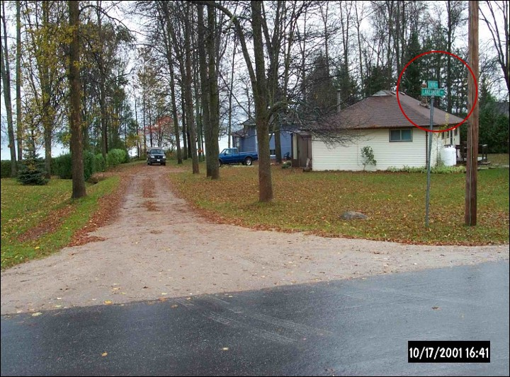
Figure 1: This single lane dirt road with an official posted street name is to be represented as part of the minimal ORN core network.
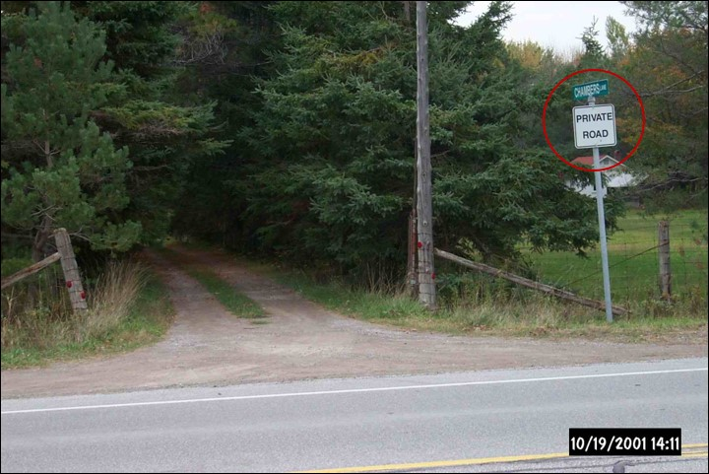
Figure 2: This single lane dirt road with an official posted street name is to be represented as part of the minimal ORN core network; where Functional Road Class: Local / Strata and Jurisdiction: Private.

      - Roads Without an Official Posted Street Name
The following roads are to be represented in the ORN regardless of whether they have an official posted street name:
- Roads that provide access to two or more dwellings.
- Roads that access a major development (mill, mine, etc.).
- Roads that access features accessible to the public (i.e. park, boat launch, etc.).

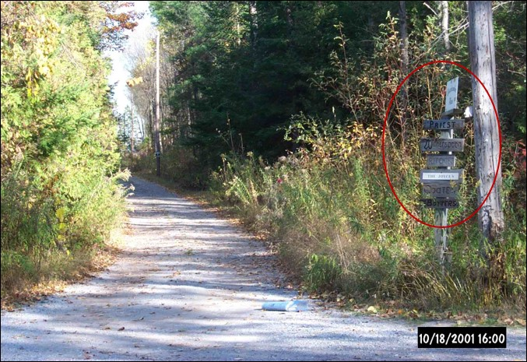
Figure 3: This single lane dirt road is to be represented as part of the minimal ORN core network as it services more than one dwelling (as evidenced by the multiple family signs).
      - MNR Resource Roads
In Ontario, community access and forestry roads are a vital component of the infrastructure used to access Crown lands, they also provide access to some of the most remote areas of the province and act as crucial routes for emergency preparedness, fire response and evacuation.
The authoritative source for Resource Roads under MNR’s jurisdiction is the MNR Road Segment dataclass. Roads from MNRF Road Segment are to be incorporated in to the ORN as they become verified by the various MNR Districts so long as they meet all the following criteria:
- FMP Road Class: Primary or Branch;
- Status: Open or Restricted;
- Passable Flag: True; and
- the segments are connected to the ORN.
These roads should be attributed as Functional Road Class: Resource / Recreation and Jurisdiction: Ministry of Natural Resources in the ORN.
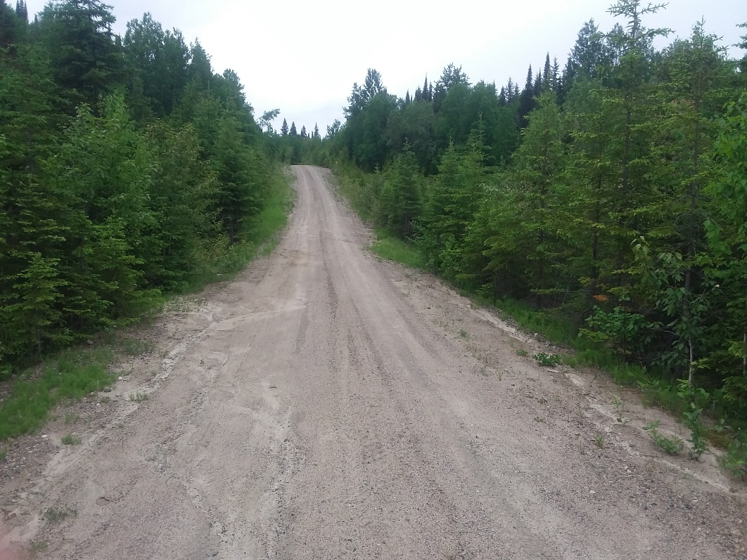
Figure 4: This single lane dirt road with a Primary FMP road classification is used for forestry operations and is to be represented as part of the minimal ORN core road network; where Functional Road Class: Resource / Recreation and Jurisdiction: Ministry of Natural Resources.
Image Source: ROD, 2016-06-22.
      - Service-Type Roads
Service-type roads such as traffic lanes and/or roads accessing weigh scales, lookouts and rest areas permitting vehicles to come to a complete stop along public roads are to be represented in the ORN. These Road Elements are to be classified with the Functional Road Class of Service.
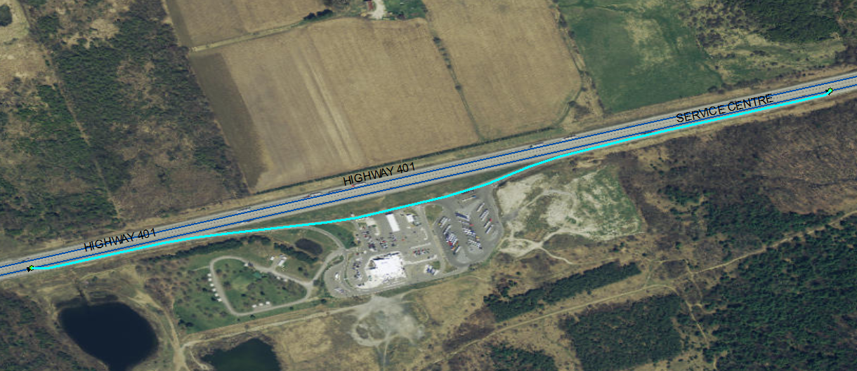
Figure 5: This service lane (highlighted) accesses the Port Hope ONroute Travel Plaza and is to be represented as part of the minimal ORN core road network; where Functional Road Class: Service (-78.431208, 43.943615 Decimal Degrees).
      - U-Turns
The following types of U-Turns are to be represented in the ORN:

Controlled Emergency or Restrictive U-Turns
Controlled emergency or restrictive U-Turns uniting divided carriageways of a freeway are to be represented as part of the minimal ORN core road network. These Road Elements are to be classified with the Functional Road Class of Service.
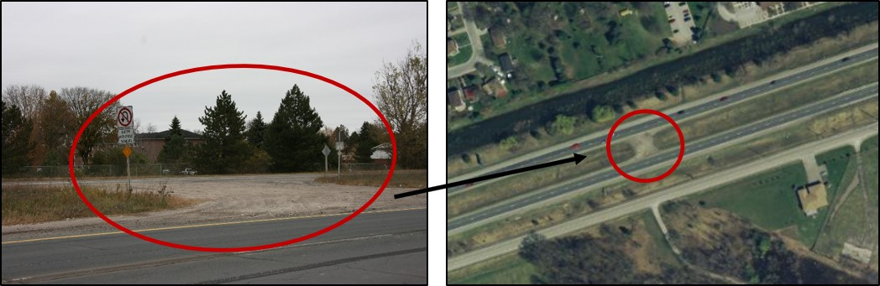
Figure 6: This emergency U-Turn uniting a divided carriageway of a Freeway is to be represented as part of the minimal ORN core road network; where Functional Road Class: Service (-78.328341, 44.270991 Decimal Degrees).

Public, Non-Restrictive U-Turns
Public, non-restrictive U-turns uniting divided carriageways of a Functional Road Class of a lower hierarchy than a Freeway are to be represented as part of the minimal ORN core road network.
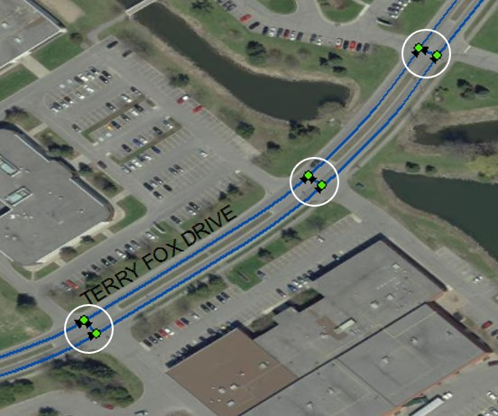
Figure 7: Public, non-restrictive U-Turns on Terry Fox Drive in the City of Ottawa (-75.919007, 45.349999 Decimal Degrees).
These short Road Elements are to be classified with the same Functional Road Class as the adjoining Road Elements, they will also adopt the same name as the adjoining road (See Figure 8).
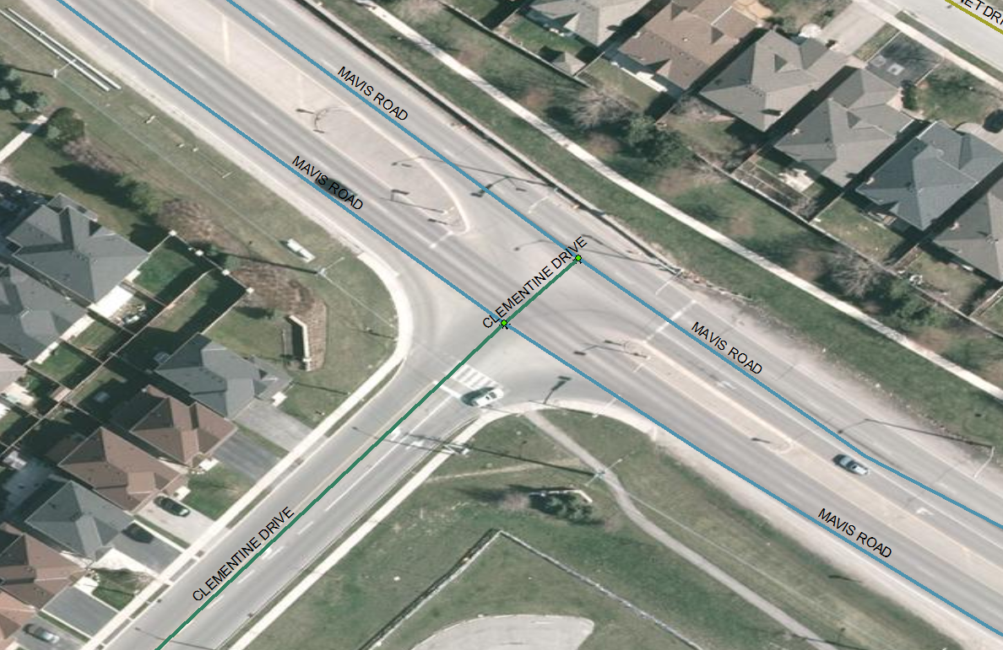
Figure 8: Mavis Road and Clementine Drive in the Region of Peel, symbolized by Road Class, demonstrating the practice of the assigning the attributes of the adjoining road to the short segments that unite divided carriageways (-79.749979, 43.643537 Decimal Degrees).

      - Winter Roads and Ice Bridges
Roads spanning a water body acting as a bridge during the winter season are to be represented as part of the minimal ORN core road network. These roads are only useable during the winter when conditions allow for passage over lakes, rivers and wetlands.
Note: Many of these ice bridges become Ferry Connections during the summer season that also need to be represented.
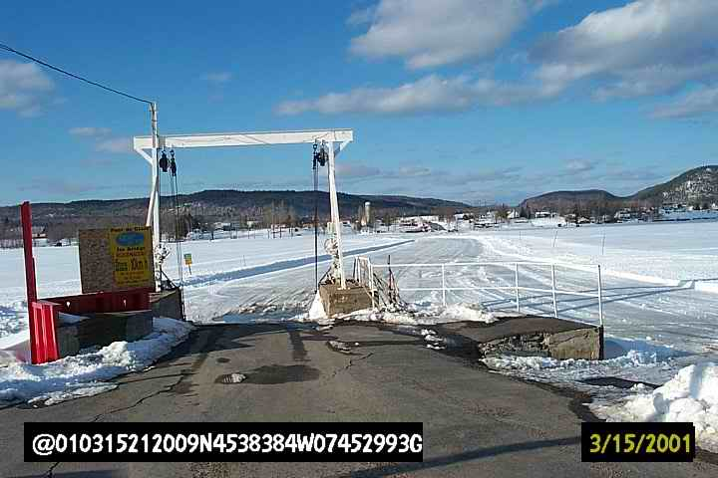
Figure 9: Ice bridge (and Ferry route in the summer) between Lefaivre, ON and Montebello, QC (-74.883275, 45.639963 Decimal Degrees).

      - New Road Construction
New roads, especially in subdivisions under development, are to be represented as part of the minimal ORN core road network if construction is visible in recent imagery and/or they have official names and addressing. This decision was made to ensure emergency management services can navigate to the scene of an emergency were there ever to be an incident on a construction site.
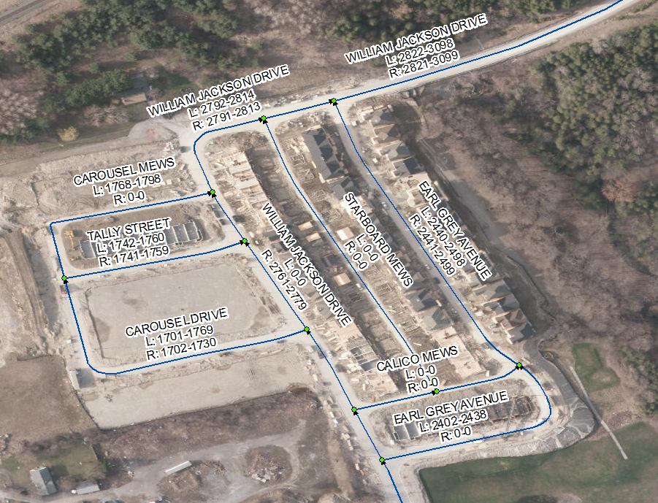
Figure 10: These new roads, whose geometry was provided by a partnering municipality but cannot yet be verified using the MNR’s most recent imagery, will be incorporated into the ORN because they are named, have addressing and there are obvious signs of development.

      - Isolated Road Networks
Roads within remote communities that are isolated from the main road network are to be represented as part of the minimal ORN core road network. These communities are accessible either by boat or by air and most of them contain an isolated road network.
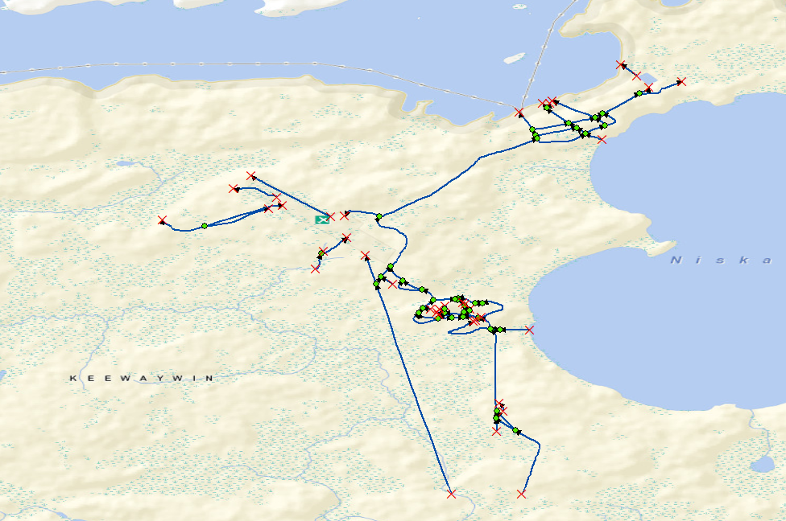
Figure 11: An example of an isolated road network in the ORN in Keewaywin First Nation (-92.835591, 52.990785 Decimal Degrees).

      - Walkways and Trails
Walkways and trails are clearly defined paths for pedestrians but can serve as a drivable surface for emergency vehicles. They are only to be represented as Road Elements in the ORN if they are driveable and attributed with addressing. To indicate that normal, public vehicular traffic is prohibited on these pedestrian walkways and trails they are to be represented with removeable Blocked Passages (See 3.3.4 Blocked Passage).
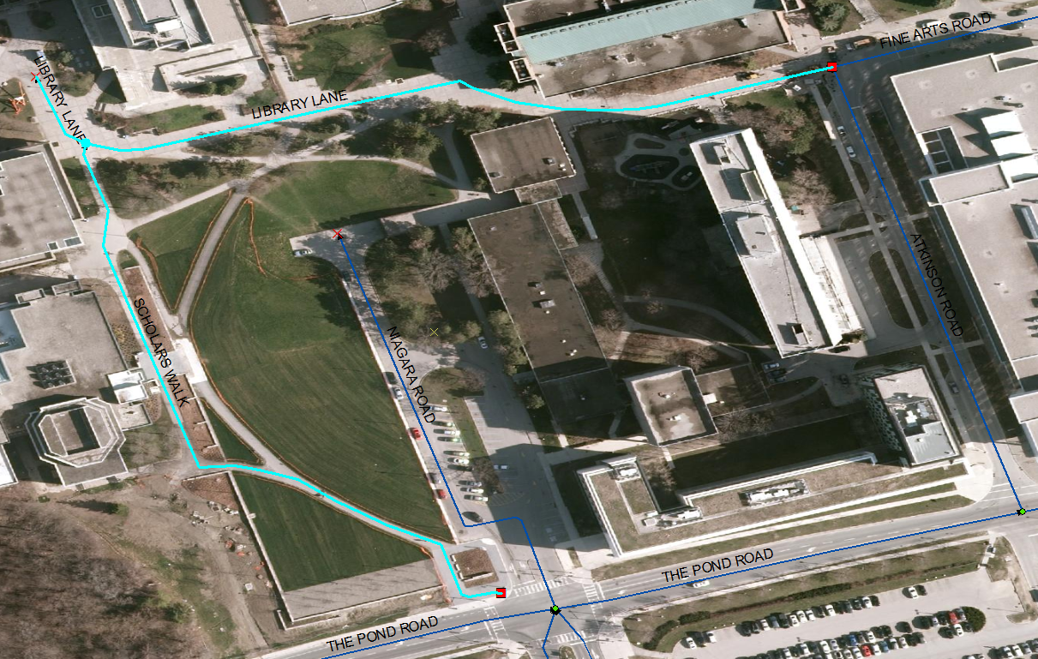
Figure 12: LIBRARY LANE and SCHOLARS WALK (highlighted) are walkways with addressing incorporated as Road Elements in the ORN. Blocked Passages are used to indicate that vehicular traffic is generally prohibited (red squares). Toronto, York University Campus (-79.503962, 43.771511 Decimal Degrees).
Non-driveable walkways or trails with addressing, such as those on the Toronto Islands that are too narrow for regular traffic, are to be represented as Virtual Roads in the ORN (See 5. Virtual Roads)
    - Optional Geometric Representation
The following sections provide recommendations for the optional geometric representation of some specific real-world phenomena in the ORN. However, should any of the following roads have official posted street signs, their representation becomes mandatory as stipulated in 3.1.1.1 Roads with an Official Posted Street Name or Address Range.
Note: Though currently not actively captured, many examples of the optional roads listed below already exist in the ORN. These optional features could have originated from the original ORN build or changing priorities throughout the ORN’s history. As it stands currently, capturing all the missing optional features across the entire province would be a large undertaking considering the difference in depth and breadth of the source data we receive from partnering municipalities.
      - Private Roads in High Density Residential Areas
The representation of private roads used to access high density residential areas (townhouse complexes, condominiums, private estates, trailer parks, etc.) in the ORN is optional. When included, these roads should be attributed as Functional Road Class: Local / Strata.
Any roads within privately maintained residential complexes that currently exist in the ORN are to be maintained. The geometry to represent any of these types of roads currently missing from the ORN is not actively captured unless provided by a partnering municipality.
      - Alleyway/Laneways
Representation of alleyways and laneways (low speed thoroughfares dedicated to providing access to the rear of properties) in the ORN is optional. When included, these roads should be attributed as Functional Road Class: Alleyway / Laneway.
Any alleyways and laneways that currently exist in the ORN are to be maintained. The geometry to represent any alleyways currently missing from the ORN is not actively captured unless provided by a partnering municipality.
      - Rapid Transitways
Representation of rapid transitways (thoroughfares restricted 24 hours a day for the sole use of public transportation buses) in the ORN is optional. When included, these roads should be attributed as Functional Road Class: Rapid Transit.
Any rapid transitways that currently exist in the ORN are to be maintained. The geometry to represent any transitways currently missing from the ORN is not actively captured unless provided by a partnering municipality.
      - Roads Within Parking Lots
Representation of the roads within parking lots (such as those encompassing shopping centres) in the ORN is optional. When included, these roads should be attributed as Functional Road Class: Local / Strata.
Any roads within parking lots that currently exist in the ORN are to be maintained. The geometry to represent any roads within parking lots currently missing from the ORN is not actively captured or added to the ORN, even when provided by partnering municipalities.
      - Roads Within Enclosed Traffic Area with Potential Public Restriction
Representation of roads within enclosed traffic areas that have a potential public restriction but could be accessed by emergency vehicles such as cemeteries, schools, hospitals, shopping centres, camp grounds or industrial sites in the ORN is optional. When included, these roads should be attributed as Functional Road Class: Local / Strata.
Any roads within an enclosed traffic area with potential public restriction that currently exist in the ORN are to be maintained. The geometry to represent any of these types of roads currently missing from the ORN is not actively captured.
      - Single Lane Access to Resource Facilities
Representation of single lane access to resources (this may include but is not limited to: water, forests, gas, oil, aggregates, energy, agriculture), communication installations and their facilities in the ORN is optional. When included, these roads should be attributed as Functional Road Class: Resource / Recreation.
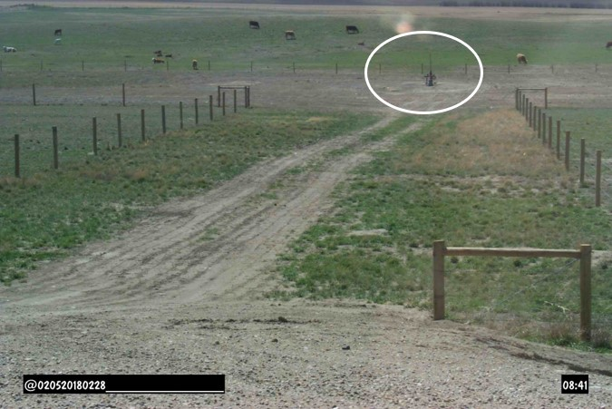
Figure 13: An example of a single lane access road used for gas or petroleum activities.
Note: These roads are differentiated from the MNR forestry access roads which have mandatory representation in the ORN. See 3.1.1.3 MNR Resource Roads.

    - Unauthorized Geometric Representation
      - Private Laneways
With the exception of those servicing two or more residential units (See 3.1.1.2 Roads Without an Official Posted Street Name), long laneways (often found in rural areas) or driveways reserved for parking owner’s vehicle(s) are not to be represented in the ORN, regardless of their length.
      - Proposed and Planned Roads
With the exception of those roads that have an official name and addressing in new subdivisions (See 3.1.1.7 New Road Construction), proposed and planned roads are not to be represented in the ORN until they are navigable by emergency vehicles.
      - Unopened Road Allowance
A road allowance is a strip of Crown land originally laid out for roads by a Crown surveyor but where no real-world road feature exists on the ground. A local municipality has jurisdiction over all road allowances located in their municipality. These real-world features are not to be represented in the ORN regardless of whether they have addressing.

  - Geometry – Positional Representation
The desired positional accuracy for each Road Element in the ORN is 10 meters or less from the road centreline.
    - Lower Left Rule
All Road Net Elements in the ORN follow the Lower Left Rule. From National Vector Data Geometric Representation and Integrity Constraints: “…the first and last coordinates must be compared in order to determine the lowest coordinates and (if equal) the leftmost (lower left rule); the coordinates must be reorganized to comply with this convention…. The computations are carried out in latitude and longitude coordinates.”
    - Road Centreline
The representation of a road corresponds to the centreline position of all the traffic lanes in accordance with the following guidelines. In cases where the centreline of the roadbed is ambiguous or discontinuous, the general flow of traffic should be used as a guideline.
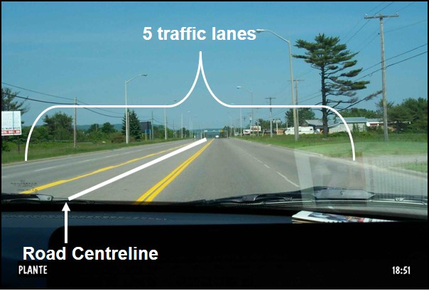
Figure 14: This road is comprised of 5 traffic lanes. Two by two driving lanes flowing in opposite directions along with a centre turning lane. The road centreline has been delineated in the centre of the turning lane (the centreline position of all traffic lanes).
The following examples describe the method used to determine the location of a road centreline:
- Shoulders bound the traffic lanes and no demarcation exist for each lane.
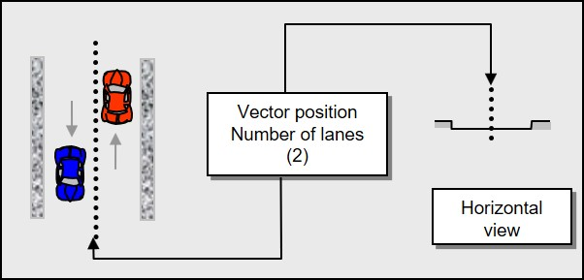
Figure 15: Interpreting the location of road centreline when no demarcations exist for each lane.

- Obstacles (shoulder and sidewalk) bound the traffic lanes and a demarcation exist for each lane.
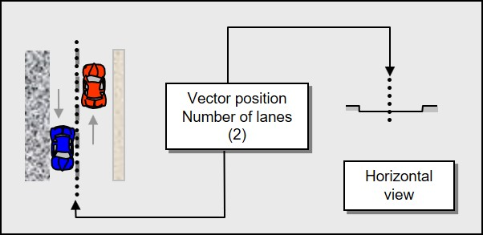
Figure 16: Interpreting the location of road centreline when obstacles bound the traffic lanes.

- Obstacles (shoulder, median strips longer than 250 m and sidewalk) bound the traffic lanes and demarcations exist for each lane.
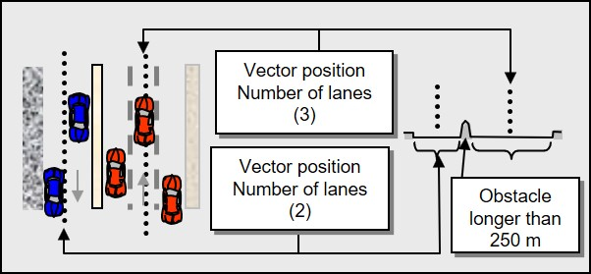
Figure 17: Interpreting the location of road centreline for dual carriageways when obstacles bound the traffic lanes.

- Obstacles (shoulder and sidewalk) bound the traffic lanes and a demarcation exists for two lanes only. Spaces alongside a road that are strictly reserved for parking vehicles are not traffic lanes and should not be considered when interpreting the location of the road centreline.

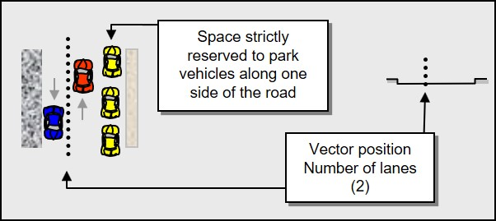
Figure 18: Interpreting the location of road centreline when obstacles bound the traffic lanes and a demarcation exists for two lanes only. A lane strictly reserved for parking vehicles should not be considered when interpreting the location of the road centreline.

- Traffic lanes and demarcations exist. Traffic lanes that are also used as parking during some defined limited times of the day should be considered when interpreting the location of the road centreline.

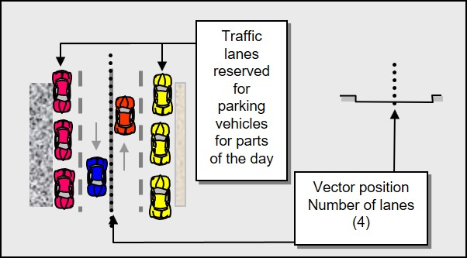
Figure 19: Interpreting the location of road centreline when demarcations exist, and traffic lanes are also used as parking during some defined limited times of the day.
    - Segmentation
The ORN is segmented at real-world intersections on the ground. Road Elements are bound by a junction on each end, except for cul-de-sacs (loops) where there is only one junction.
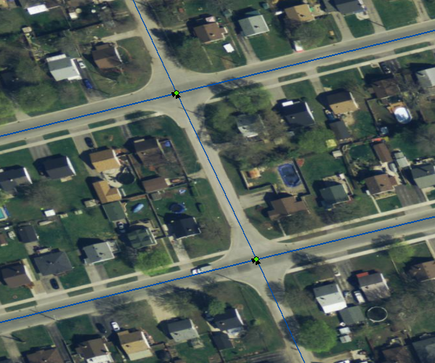
Figure 20: A bird’s eye view of real-world intersections as represented in the ORN in the City of Peterborough (-78.323932, 44.282614 Decimal Degrees). Note the junctions indicated with a green circle.
      - Grade Separated Road Crossings
Representation of a grade separated road crossing must involve a road structure (usually a bridge and underpass). No segmentation should occur between overlapping features.
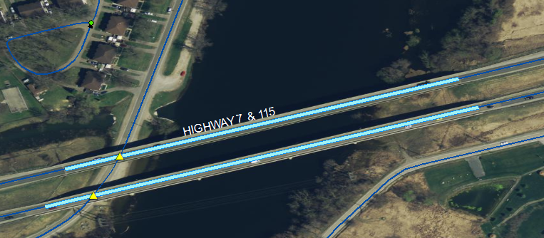
Figure 21: A bird’s eye view of a real-world grade separated road crossing, a bridge over both Johnston Drive and the Otonabee River in the City of Peterborough, as represented in the ORN (-78.323849, 44.272039 Decimal Degrees). Note the bridge indicated with a thick light blue line and the underpasses with yellow triangles.

    - Cul-de-Sac
A cul-de-sac is a dead-end street with only one inlet/outlet, particularly one with a bulbous end for turning around. The example below illustrates the recommended methods for capturing real-world occurrences of cul-de-sacs ending with or without a physical barrier to travel forming a loop.
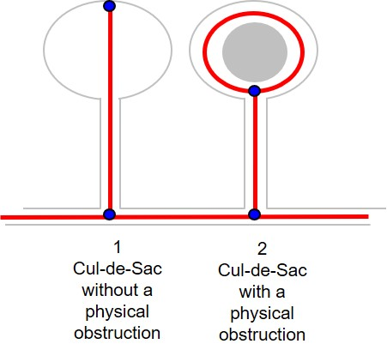
Figure 22: The recommended method for capturing real-world occurrences of cul-de-sacs ending with or without a physical barrier to travel.
In Figure 22, Cul-de-Sac 1 does not have a physical obstruction and the Road Element is therefore represented as a straight line. Due to the physical barrier to travel in Cul-de-Sac 2 the Road Element is represented as a loop. The following example provides a bird’s eye view of different types of cul-de-sac and the recommended method of representation in the ORN.
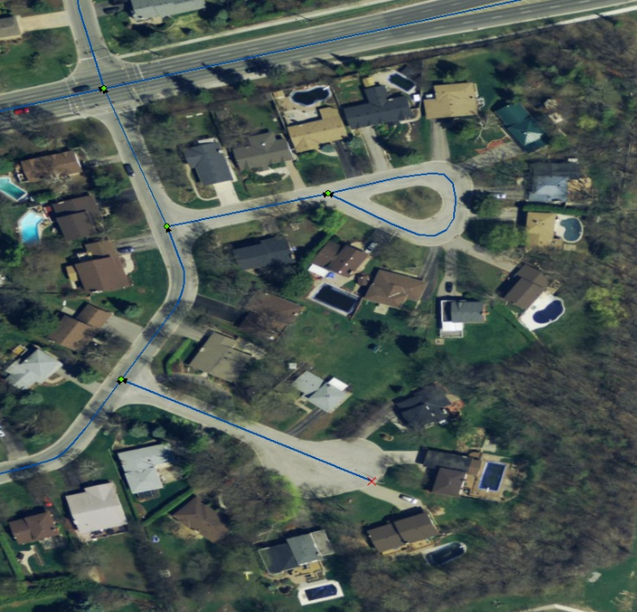
Figure 23: A bird’s eye view of real-world cul-de-sacs as represented in the ORN, in the City of Peterborough (-78.346306, 44.308381 Decimal Degrees).

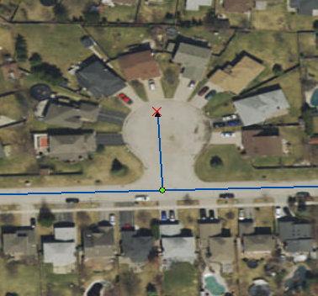
Figure 24: A bird’s eye view of a less common style of cul-de-sac and the recommended representation in the ORN, in the City of London (-81.311896, 42.993115 Decimal Degrees).

    - Divided Carriageways, Lanes and Ramps (Median Strips)
Carriageways/lanes that are separated by a median (not crossable; physical barrier) 250 metres in length or longer are to be represented as individual road segments diverted around the median.
Based on average lane widths and minimal physical obstruction sizes, parallel, single lanes separated by a median should be separated by at least four meters.
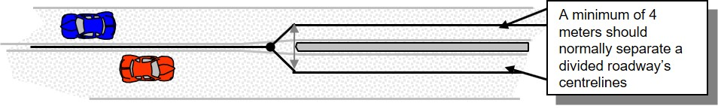
Figure 25: The recommended geometrical representation for divided carriageways (dual lanes) in the ORN, when separated by a median that is 250 metres in length or longer.
      - Short Median Strip (Guaranteed Size)
Medians that are less than 250 metres in length may not be considered.
In Figure 26, below, two medians of different sizes dictate how the Road Elements are to be represented in the ORN. The median on the left is greater than 250 metres in length and therefore the Road Elements are represented with dual line geometry. The median on the right is less than 250 metres in length and the Road Element is represented with single lane geometry.
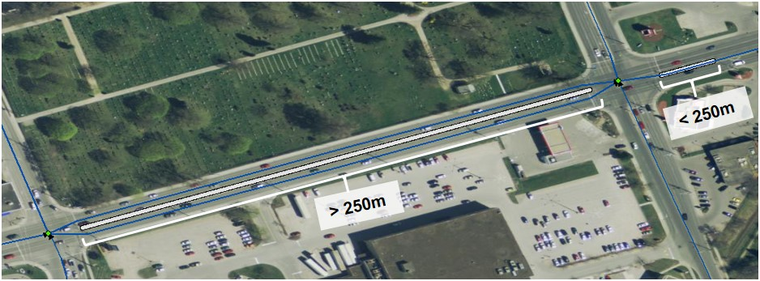
Figure 26: An example of two medians in the City of Peterborough (-78.331554, 44.285398 Decimal Degrees). The median on the left is greater than 250 metres in length requiring dual lane geometry and the median on the right is less than 250 metres in length requiring single lane geometry.
      - Multi-Lane Road Intersection (No Ramps)
Examples of common multi-lane intersections and their recommended representation in the ORN can be seen in Figure 27 below.
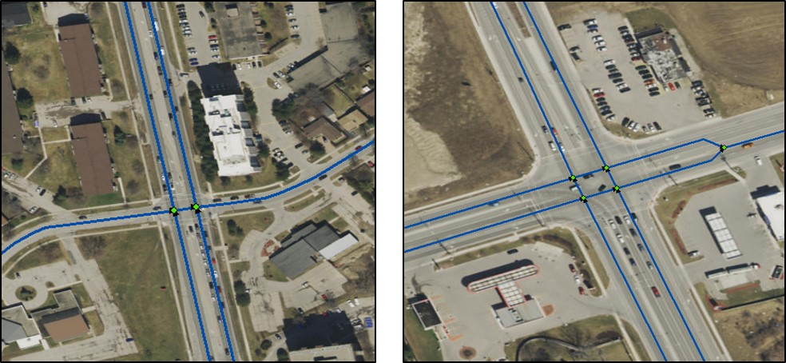
Figure 27: Examples of common multi-lane intersections and their recommended representation in the ORN.

      - Complex Urban Road Intersection Involving Ramps and Median Strips
The following image provides a bird’s eye view of a complex intersection that can be found in most major urban centers. It involves median strips, secure access ramps, pedestrian islands and multilane traffic zones.
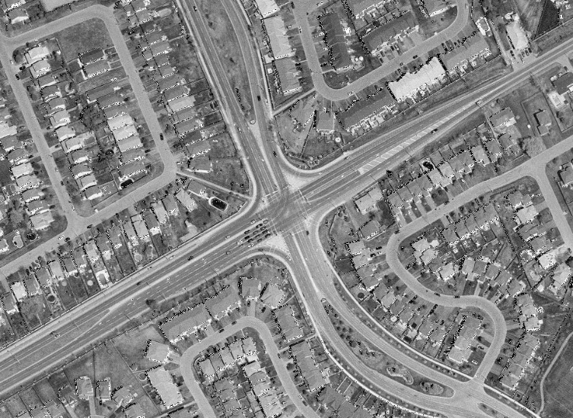
Figure 28: A bird’s eye view of a complex intersection found in most major urban centres.
Recommended method for representation within the ORN (All roads are represented as per ISO 14825, Level-1 requirements and secure access ramps are portrayed to their fullest extent):
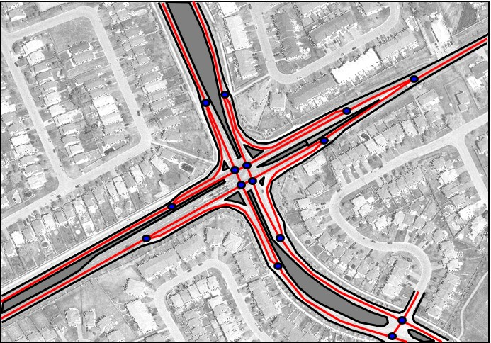
Figure 29: The recommended method for representing the intersection in Figure 28 in the ORN.
      - Freeway Ramps
Ramps are represented from the furthest points of the lane demarcations (not from the physical lane separation point (i.e. the bull nose)), as per the ISO 14825 Level-1 acquisition requirements.
The following example provide a bird’s eye view and “streets view” perspective of the recommended method for representing a set of freeway access and exit ramps.
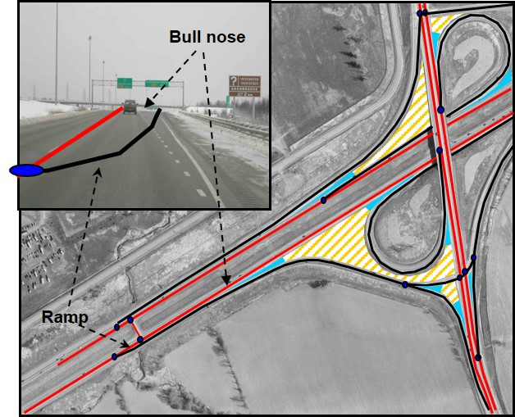
Figure 30: The recommended method for representing freeway ramps illustrating that Ramps are represented from the furthest points; that being the beginning and end of the ramp as indicated by the demarcations on the roadway.
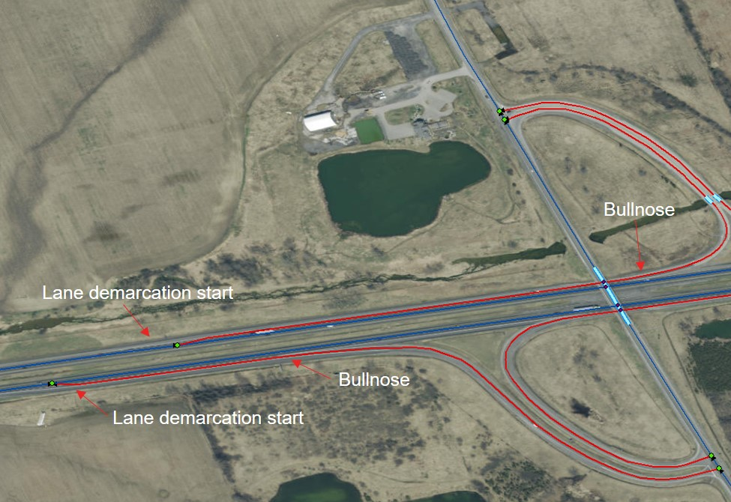
Figure 31: An example of a Ramp (red) as represented in the ORN with bullnoses and lane demarcations noted (-77.114012, 44.237557 Decimal Degrees).

      - Deflection Angle for Merging Roads
The angle at which centrelines are merged in the ORN is based on actual driving habits. Both normal road speeds and reasonable driving requirements contribute towards what constitutes as an appropriate minimum deflection angle. For a full description of the logic behind the recommended merging angles see 10. Appendix A: Merging Angles.
As a minimal requirement, merging angles should never exceed ninety degrees. An angle of sixty degrees is recommended.
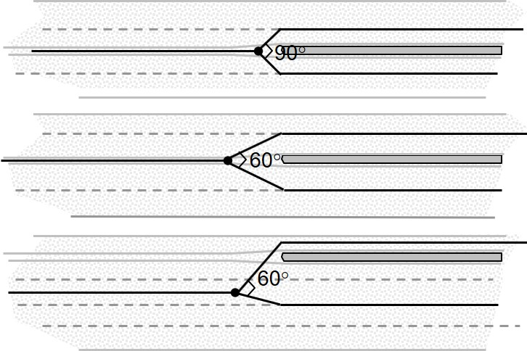
Figure 32: Recommended practice for representing merging angles in the ORN is sixty degrees; they should never exceed ninety degrees.

    - Slip Lanes (Turning Lanes)
Slip Lanes, right hand turning lanes diverting traffic around a barrier to travel, are to be represented in the ORN. Slip lanes should be captured and merged with main segments in a similar fashion to Ramps. They are classified (Road Class) and addressed (Street Name) to match the Road Class and Street Name of the ‘From’ road.
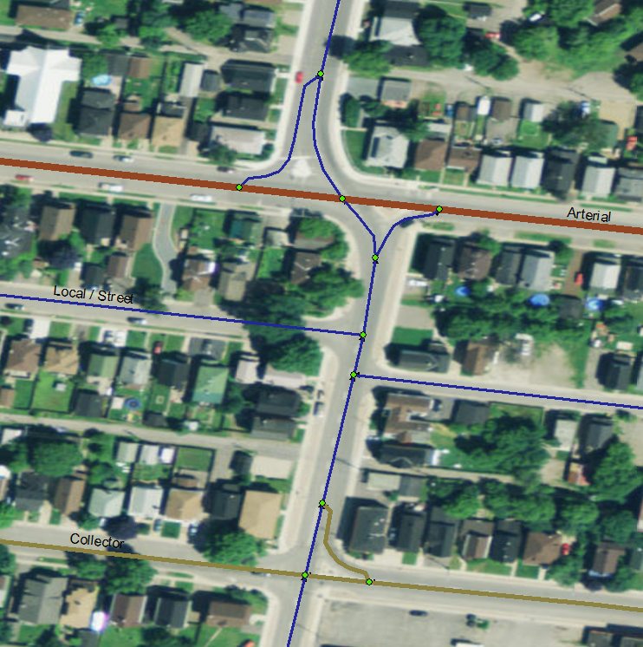
Figure 33: Recommended practice for representing Slip Lanes in the ORN in Sault Ste Marie (-84.341489, 46.519909 Decimal Degrees). The Road Elements have been symbolized by road class to illustrate that the Slip Lanes adopt the same road class as the ‘From’ road.

Left hand turning lanes at intersections are not to be captured as separate Road Elements unless a physical barrier exists. See example in Figure 34.
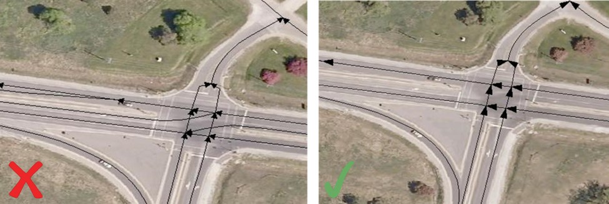
Figure 34: Recommended practice is to not capture left hand turning lanes (as shown in the image on the left). The image on the right represents the proper representation of multi-lane intersections with left hand turning lanes in the ORN.

    - Passing Lanes for Through Traffic
As a minimal requirement, road widenings longer than 1000m accommodating for passing lanes or through traffic circulation at road intersections should be considered when defining the road centreline and number of lanes.
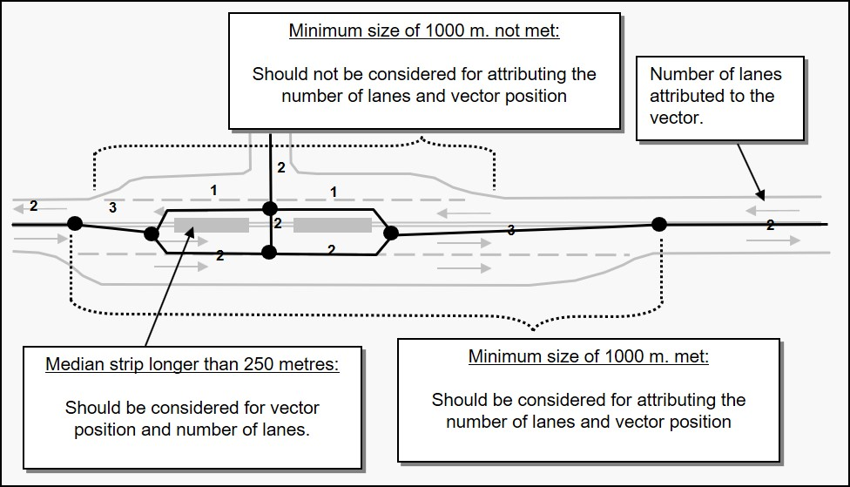
Figure 35: Recommended vector position and attribution for road widenings longer than 1000 metres.

    - Roundabouts (Traffic / Turning Circles)
A roundabout is a circular intersection where two or more roads meet. They are represented by single line geometry except where lanes are divided by a barrier to travel, such as the on and off lanes in the image below. The Road Elements in a roundabout are to be classified with the same Functional Road Class as that of the highest order classification of the intersecting roads.
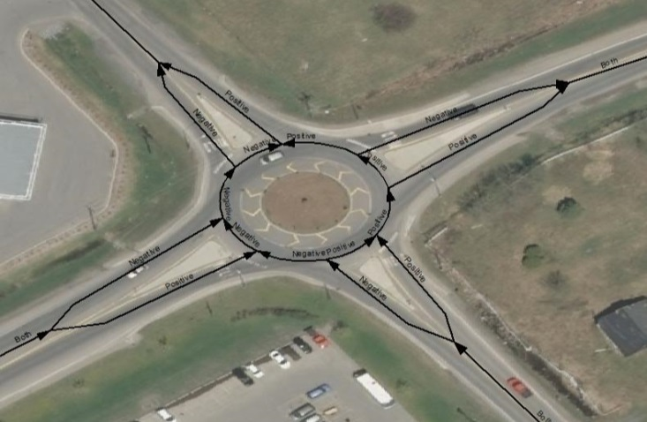
Figure 36: Recommended representation of a roundabout in the ORN. Note the geometry of the Road Elements in a roundabout follow the Lower Left Rule and the direction of traffic flow is specified as positive or negative with respect to the direction of the geometry.

    - Undefined Route (Winter Roads and Ice Bridges)
The average route of winter roads and ice bridges over water are to be represented in the ORN. A detailed representation is not required as the route may vary from season to season. Over land, representation should mirror its actual path where it exists and is re-used every season.
Winter roads and Ice Bridges are not subject to the 10m positional accuracy requirement.
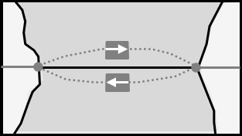
Figure 37: The representation of winter roads and ice bridges should mirror its average route over water.

    - Minimum Size of a Road Element (from Junction to Junction)
A Road Element being the representation of the centreline of a road from Junction to Junction, its length should never be shorter than half the width of a lane. Considering that a single lane is approximately 3.5 metres wide, the representation of a dead-end road, from junction to junction, should be at least more than 1.75 metres long when it is accessible from a single lane road. Therefore, the minimum size for a Road Element, from junction to junction, is set to 2 metres.

Figure 38: The minimum size for a Road Element from junction to junction is 2 metres.

When two roads of an intersection meet with a slight offset that is less than the minimum size of a Road Element, their representation should meet at a junction located at mid-point between the two as shown in Figure 39, below.
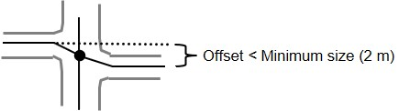
Figure 39: Recommended representation of an intersection when two roads meet with a slight offset that is less than the minimum size of a Road Element (2 metres).
If the offset is more than the minimum size of a Road Element, they should be represented by two road intersections formed by three roads as shown in Figure 40, below.
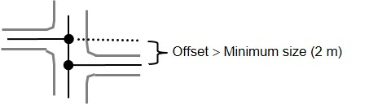
Figure 40: Recommended representation of two intersections when the offset between Road Elements is more than the minimum size of Road Element (2 metres).
Note: any attribute change occurring on a distance shorter than the minimal size should not be considered.
    - Roads Crossing Administrative Boundaries
Road representation across municipal and provincial boundaries must be seamless and road centrelines must connect.

  - Attributes – Thematic Representation
The ORN is maintained as an LRS consisting of a set of line features on which events, elements and characteristics can be located based on a reference to the line itself. Road Elements have several allowable events to describe the addressing and various characteristics of road segments. The following are the main business area tables that describe Road Elements in the ORN (presented alphabetically).
Any attribute change occurring on a distance shorter than the minimal size of a Road Element (2m) should not be considered.
Note: Most event tables that follow will contain the name of the source Agency providing geometry or attribute information. This is represented by either a Municipal Name, a Provincial Ministry, a Federal Agency or the Ontario Road Network and is subject to change upon any revisions to the attributes.
    - ORN Road Element Feature Table
      - Direction of Traffic Flow
The direction(s) of vehicular or motor traffic flow. All Road Elements must have a direction of traffic flow assigned. Direction of traffic flow is reference with respect to the direction of digitizing.
See Table 1 for the list of valid direction of traffic flows.
Table 1: Valid values for Direction of Traffic Flow as represented in the ORN.
Direction of Traffic Flow | Description
Both | Traffic is allowed in both directions.
Negative | Traffic is opposite to the direction of the geometry.
Positive | Traffic is the same direction as the geometry.

      - Exit Number
Where posted, Exit Number refers to the number of an exit on or off a Freeway, Expressway or Highway, assigned by an administrating body and represented by a valid number or character. Access ramps do not have exit numbers assigned.
In the following example, the Exit Number 51 can be seen on the exit sign itself (Figure 41).
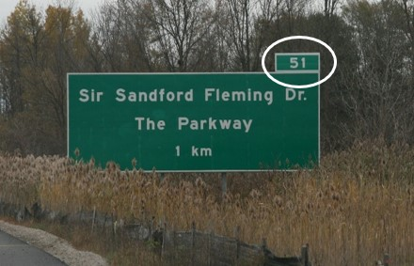
Figure 41: The Exit Number for The Sir Sandford Fleming Dr./The Parkway exit from Hwy 115 into Peterborough is 51, as indicated in the image above. This number should be associated with the main Road Net Element feature in the ORN.
In the following example, the Exit Number 49 can be seen at the exit itself (Figure 42).
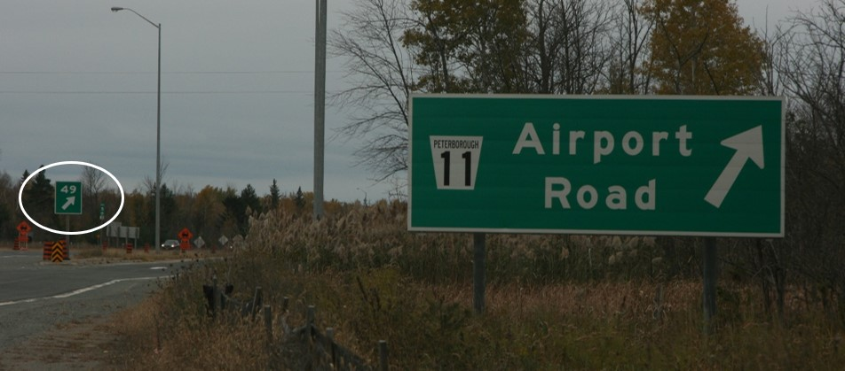
Figure 42: The Exit Number for the Airport Road exit from Hwy 115 into Peterborough is 49, as indicated in the image above. This number should be associated with the main Road Net Element feature in the ORN.

Exit Numbers on Junctions
When a road segment portrays a one-way ramp with an exit number, only the Junction marking its point of entrance is assigned with the same Exit Number.
      - Toll Road Indicator
The Tool Road Indicator indicates whether the Road Element is a toll road.
Permissible values:
- Yes
- No
      - Acquisition Technique
The Acquisition Technique refers to the type of data source or technique used to create or revise a Road Element in the ORN.
See Table 2 for a list of permissible values.
Table 2: Valid values for Acquisition Technique as represented in the ORN.
Acquisition Technique | Description
Aerial Photo | Aerial photography not ortho-rectified.
Computed | Geometric information that has been computed (not captured).
Digital Elevation Model | Data coming from a Digital Elevation model (DEM).
Field Completion | Information gathered from people directly in the field.
GPS | Data collected using a GPS device.
None | No value applies.
Orthoimage | Satellite imagery ortho-rectified.
Orthophoto | Aerial photo ortho-rectified.
Other | All possible values not explicitly mentioned in the domain.
Paper Map | Conventional sources of information like maps or plans.
Raster Data | Data resulting from a scanning process.
Raw Imagery Data | Satellite imagery not ortho-rectified.
Unknown | Impossible to determine.
Vector Data | Vector digital data.
    - Address Information
In the ORN, address information in the form of the essential components of a street address are collected and stored as events relating to the left or right side of the street or Road Element. Addressing is collected and maintained by an authoritative source such as the municipality, county or region for the purposes of assisting in the delivery of 911 services.
Addressing in the ORN is mandatory when provided by the authoritative source.
See Section 7. Address Range below.
    - Alternate Street Name
A linear event identifying an alternate street name to Official Street Name (See 3.3.8 Official Street Name). This name may be associated with a bilingual name.
    - Blocked Passage
A point event on a Road Element identifying the existence of an access barrier or an obstruction, either human-made or natural, which controls or limits access to the Road Element.
      - Blocked Passage Type
Table 3: Valid values for Blocked Passage Type as represented in the ORN.
Blocked Passage Type | Blocked Passage Type Description | Examples
Permanent | An obstacle placed across a Road Element that must be removed or destroyed to free the entrance to the other side of the road that it is blocking. | Concrete blocks, fixed gates, anchored steel posts, mounds of earth and/or debris, culvert or bridge removed
Removable | A man-made barrier designed to block the entrance to the other side of the Road Element but that will also easily allow further access when so desired. | Swing gates, removable anchored (locked) steel post and wooden poles
      - Impassable Obstacle (Guaranteed Size)
When an impassable obstacle (trench, natural washout, removed culvert or bridge, rock berm) occurs over a distance shorter than 2 metres if should be represented as a single permanently fixed blocked passage.
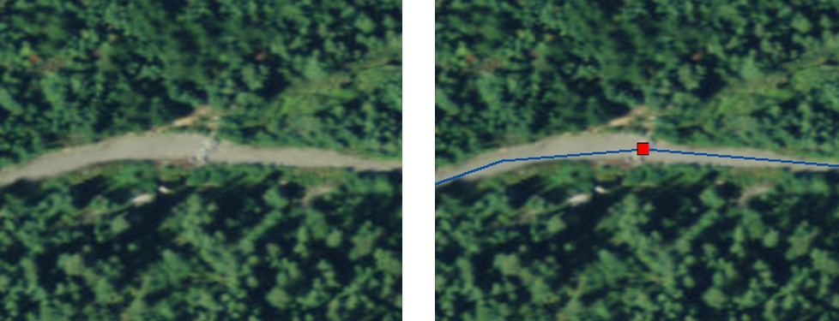
Figure 43: This berm (on left) is less than 2 metres in length and is therefore represented as a single permanently fixed blocked passage in the ORN (the red square in the image on the right).
When the obstacle is longer than 2 metres it should be represented by two dead end junctions causing the road feature to be represented by two distinct Road Elements. In the following example the bridge is obstructed by what appears to be concrete barriers, because the barrier to travel is longer than 2 metres the obstruction to travel is represented by two dead ends.
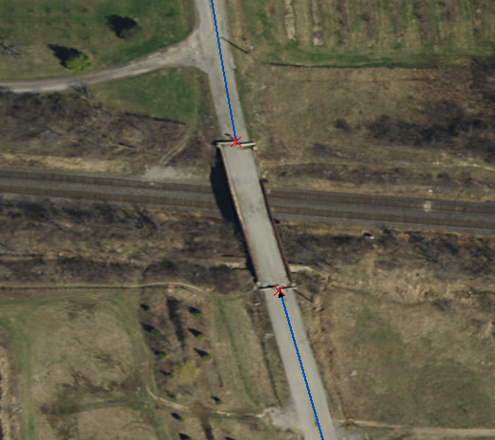
Figure 44: In the ORN, two dead end junctions represent this obstruction to travel that is greater than 2 metres.
      - Dead End vs Blocked Passage

Dead End
When no real-world intersection exists between two Road Elements, even though it may only be a sidewalk or a stretch of grass that separates them, it must be interpreted as a Junction-type Dead End.
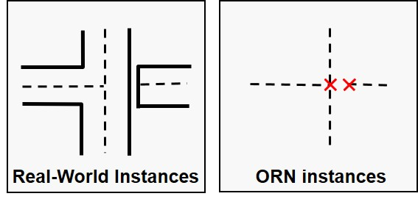
Figure 45: No real-world intersection exists between these two Road Elements. They are therefore bound by Dead End junctions, the red X’s, in the ORN.

Blocked Passage
When a real-world intersection exists between two Road Elements and one of these is made inaccessible by introducing an obstacle then this instance shall be deemed a Blocked Passage.
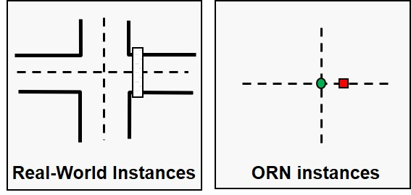
Figure 46: An inaccessible real-world intersection represented with a Blocked Passage.

    - Junction
A junction identifies the connectivity of Road Elements. All ORN Road Elements begin and end at a junction.
See Section 6. Junction below.
    - Jurisdiction
A linear event identifying the jurisdictional or custodianship responsibility for a Road Element. The custodian would have the responsibility to ensure maintenance occurs but is not necessarily the one who undertakes the maintenance directly.
    - Number of Lanes
A linear event indicating the number of lanes of a Road Element.
Road widenings longer than 1000m accommodating for passing lanes or through traffic circulation at road intersections should be considered when attributing number of lanes.
      - Number of Lanes on Paved Roads
On most paved roads the number of traffic lanes can be delineated from imagery or inferred from road width. Refer to the definition of road centreline (3.2.2 Road Centreline) for guidelines on how to interpret traffic lanes.
      - Number of Lanes on Loose Surface Roads
When lane demarcation is not present, as for all loose surface roads, the number of lanes must be interpreted.

As a guideline, if the drivable portion of the roadbed of a loose surface road is less than 5 metres wide, the road should be assigned one lane (See Figure 47).
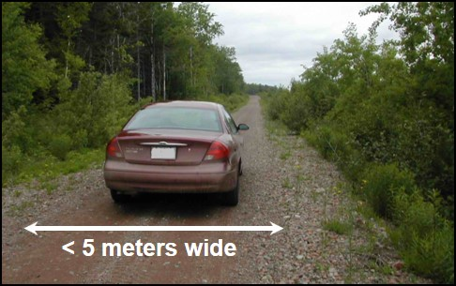
Figure 47: This roadbed is less than 5 metres wide. It should be assigned one lane in the ORN.
Loose surface roads can never have a value greater than 2 lanes assigned to them (See Figure 48).
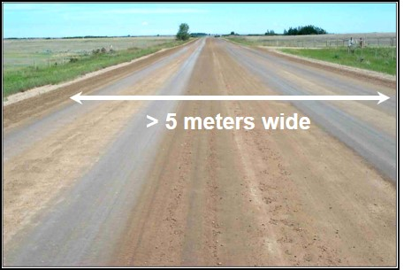
Figure 48: This roadbed is several metres wide but should only be assigned two lanes in the ORN.

      - Number of Lanes in a Complex Intersection
Figure 49 below depicts a complex intersection and the recommended convention for assigning Number of Lanes in the ORN.
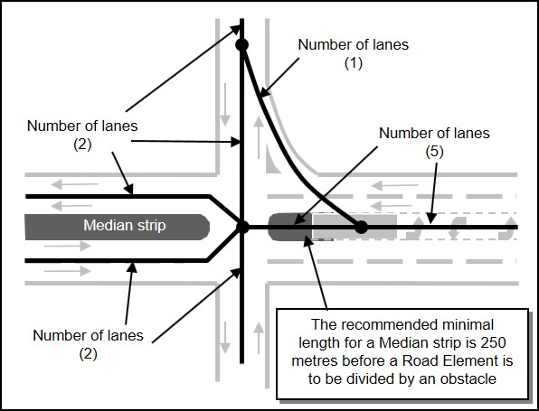
Figure 49: A complex intersection and the recommended convention for assigning Number of Lanes in the ORN.
    - Official Street Name
A linear event identifying the Official Street Name of a Road Element. Where multiple Official Street Names may exist (Ottawa Street and Highway 7 in Havelock, for example), the local name is taken as the Official Street Name in the built-up area and the county/regional/provincial name is added to the Alternate Street Name table.
Full Street Name in the Official Street Name table is derived from the individual street name components where present, namely directional prefix, street type prefix, street name body, street type suffix and directional suffix and is stored in upper case text.

    - Road Class
A linear event identifying the Road Class of a Road Element based on a functional classification schema.
The ORN Road Class data standards are based on those of the National Road Network; a combination of both the defined ISO 14825 hierarchy along with the Transportation Association of Canada vocabulary and classification system (updated in June 2017).
Though there are many similarities between the ORN Functional Road Classification system and the classification systems that are used by data providers across the province; each of these differ slightly from region to region or jurisdiction to jurisdiction.
The following section will describe as best as possible the hierarchy of Functional Road Classes in the ORN.

      - Relationship Between Road Classifications
Figure 50, below, illustrates the desirable interrelationships of the six groups of road classifications extracted from the Geometric Design Guide for Canadian Roads (TAC, June 2017).
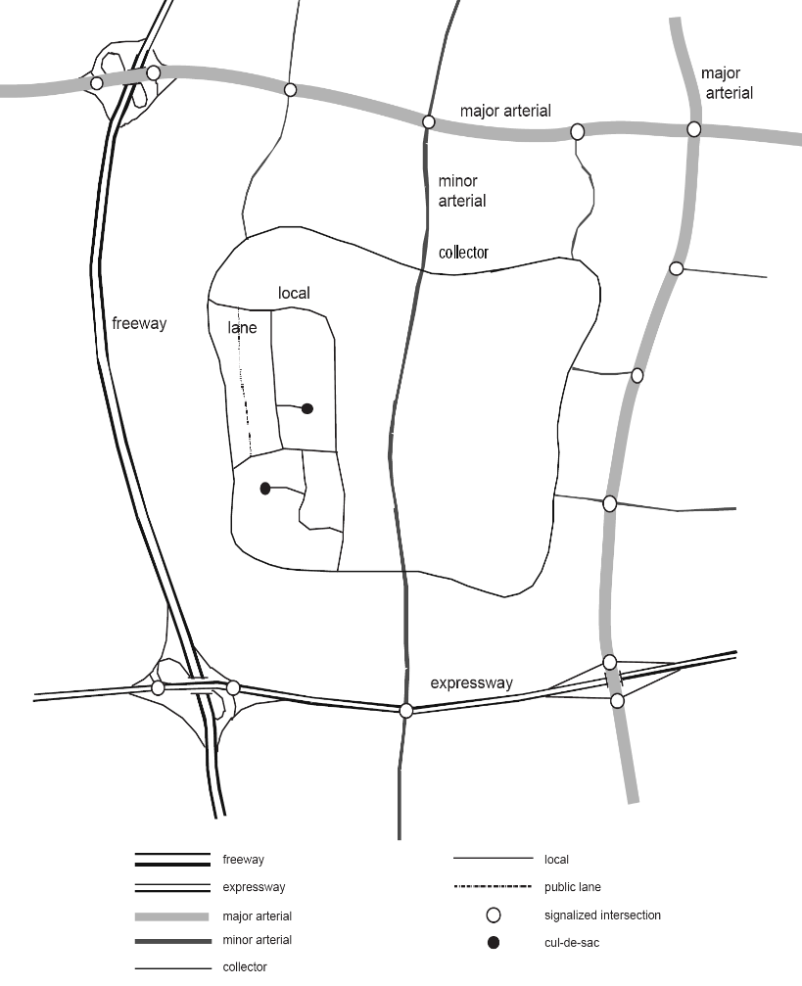
Figure 50: This figure illustrates the desirable interrelationships of the six groups of road classifications extracted from the Geometric Design Guide for Canadian Road (TAC, June 2017).
      - Functional Road Class Integrity
A Functional Road Class should not change on the length of a road structure (bridge, tunnel) and the road structure should have the same Functional Road Class as one of the road segments to which it is connected.
Roads with the Functional Road Class of Freeway, Highway, Arterial and Ramp should not form a closed loop.
      - Road Classification Descriptions
Descriptions of the Functional Road Classifications used in the ORN. Each road class is preceded by the NRN ranking (a hierarchy of sorts) in parenthesis.

(1) Freeway
An unimpeded, high-speed controlled access thoroughfare for through traffic with typically no at grade intersections, usually with no property access or direct access and which is accessed by a ramp. Pedestrians prohibited.

(2) Expressway / Highway
A high-speed thoroughfare with a combination of controlled access and intersections at grade level.

(3) Arterial
A major thoroughfare with medium to large traffic capacity.

(4) Collector
A minor thoroughfare mainly used to access properties and to feed traffic with right of way.

(5) Local / Street
A low-speed thoroughfare dedicated to providing full access to the front of properties.

(6) Local / Strata
A low-speed thoroughfare dedicated to providing access to properties with potential public restriction such as Provincial Parks, Conservation Areas, trailer parks, First Nations, condominiums and private estates.

(7) Local / Unknown
A low-speed thoroughfare dedicated to providing access to the front of properties but for which the access regulations are unknown. Use of this Road Class should be minimized.

(8) Alleyway / Lane
A low-speed thoroughfare dedicated to providing access to the rear of properties.

(9) Ramp
A system of interconnecting roadways providing for the controlled movement between two or more roadways.

(10) Resource / Recreation
A narrow passage which has as a primary function access for resources extraction and may have a role in providing an access for the public to back country.
Note: Resource road surface may vary considerably from one region to another.

MNR Resource Roads
The official authoritative source for Resource Roads under MNR’s jurisdiction is the MNR Road Segment dataclass. Roads from MNR Road Segment are to be incorporated in to the ORN as they become verified by the various MNR Districts so long as they meet all the following criteria:
- FMP Road Class = Primary or Branch
- Status = Open or Restricted
- Passable Flag = True
- Connected to the ORN

(11) Rapid Transit
A thoroughfare restricted 24 hours a day, for the sole use of public transportation buses.
Note: A traffic lane reserved in part for public transport shall be deemed a normal traffic lane.

(12) Service
A stretch of road permitting vehicles to come to a stop along a Freeway or Highway. These include weigh scales, service lanes, emergency lanes, lookouts, rest areas and controlled emergency or restrictive type U-Turns uniting divided highways.

(13) Winter Road
A road that is only useable during the winter months when conditions allow for passage over lakes, rivers and wetlands.
Many of these ice bridges become Ferry Connections during the summer season and must be represented separately as such.

      - Characteristics of Urban Roads
The following table has been adapted from Transportation Association of Canada (2017) and applies to the characterization of urban roads.
Table 4: Characterization of Urban Roads, adapted from TAC (2017).
 | Alleyway / Lane | Locals | Collectors | Arterials | Expressways / Highways | Freeways
Traffic Service Function | Traffic movement not a consideration | Traffic movement secondary consideration | Traffic movement and land access of equal importance | Traffic movement major/primary consideration | Traffic movement primary consideration | Optimum mobility
Land service / access | Land access only function | Land access primary function | Traffic movement and land access of equal importance | Some/rigid access control | No access | No access
Flow characteristic | Interrupted flow | Interrupted flow | Interrupted flow | Uninterrupted flow except at signals and crosswalks | Uninterrupted flow except at signals | Free flow (grade separated)
Average running speeds (km/h) (off-peak) | 20-30 | 20-40 | 30-70 | 40-60 | 50-90 | 70-110
Desirable connection | Alleyway / lanes, locals | Alleyway / lanes, locals, collectors | Locals, collectors, arterials | Collectors, arterials, expressways, freeways | Arterials, expressways, freeways | Arterials, expressways, freeways
Accommodation of Cyclists | No restrictions or special facilities | No restrictions or special facilities | Special facilities considered | No restrictions; special facilities considered | Cyclists permitted unless specifically posted otherwise | Prohibited
Accommodation of Pedestrians | Pedestrians permitted, no special facilities | Sidewalks on one or both sides or where required | Sidewalks provided both sides or where required | Sidewalks may be provided, separation for traffic lanes preferred | Pedestrians permitted unless specifically posted otherwise | Pedestrians prohibited
Parking (typically) | Some restrictions | No restrictions or restrictions one side only | Few restrictions other than peak hour | Peak hour restrictions or prohibited | Prohibited | Prohibited
Right-of-way width (m) (typically) | 6 – 10 | 15 – 22 | 20 – 24 | 20 – 45 | >452 | >602

    - Road Net Element Source
A linear event identifying the source agency, Municipality, Provincial Ministry, Federal Agency or other organization that provided the Road Element.
    - Road Surface
A linear even identifying the surface type of a Road Element.
      - Pavement Status
The type of improvement applied to a road surface. Paved or Unpaved.

Paved
A road with a surface made of hardened material such as concrete, asphalt, tar gravel or steel decks.

Unpaved
A road with a surface made of loose material such as gravel or dirt.

      - Surface Type
A description of the road surface (Valid values: Blocks, Dirt, Flexible, Gravel or Rigid)
Table 5: Valid values for assigning Road Surface in the ORN.
Pavement Status | Surface Type | Surface Type Description | Examples
Paved | Flexible | A paved Road Element with a flexible surface. Paved road surfaces are primarily made up of asphalt. Surface quality varies across the province.  It is a common occurrence in rural areas to have roads that are a mixture of rocks and ‘cold tar’. Though the surface is not as smooth as standard asphalt it is not subject to any grading work. | Asphalt, tar gravel
Paved | Rigid | A paved Road Element with a rigid surface. | Concrete, bridges with steel surfaces
Paved | Blocks | A paved Road Element with a surface made of blocks. | Cobblestones, interlocking pavers
Unpaved | Gravel | An unpaved Road Element which the surface has been improved by grading with gravel.  Gravel roads are primarily comprised of rocks. The surface is subject to grading maintenance.
    - Route Name
A linear event identifying the route name attached to a Road Element as defined by a Municipality, Provincial Ministry, or Federal Agency and which is associated to an established and/or maintained route. A Road Element can belong to more than one named route and in such cases, it has multiple Route Name events. Freeways and Highways may have a route name rather than a route number as a source of identification. When a French or English equivalent of a Route Name does not exist, the equivalent field is left blank.
Route Names should not have gaps across their span and the names should extend to associated service lanes and ramps.
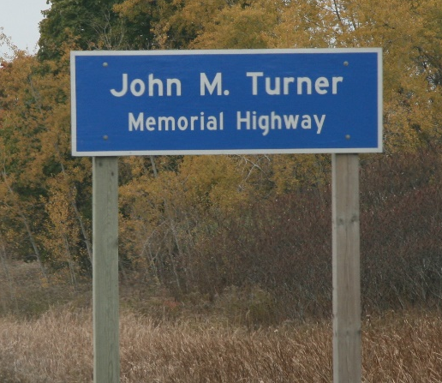
Figure 51: Highway 7 & 115 extending from the border of the County of Peterborough to Lansdowne St. E in the City of Peterborough also has the following named route: John M Turner Memorial Highway.

      - Mandatory Route Names: Trans Canada Highway & Route Trans Canadienne
“Trans Canada Highway” and its French equivalent “Route Transcanadienne” are the only mandatory Route Names to populate where applicable.
      - Optional Route Names
Provision of other Route Names aside from the Trans Canada Highway is optional.
Scenic Route Names along Highways and Collectors is also optional.
    - Route Number
A linear event identifying the route number attached to a Road Element as defined by a Municipality, Provincial Ministry, or Federal Agency and which is typically associated with provincial highways, secondary highways, county roads and regional roads.
When a route number starts at a road interchange, its starting and ending point should coincide with its furthest ramp access.

A single Road Element may have more than one route number assigned. In the following example the Road Elements would be populated with:
- Route Number 1: 7
- Route Number 2: 115
- Directionality (West and South) is not part of the Route Number value

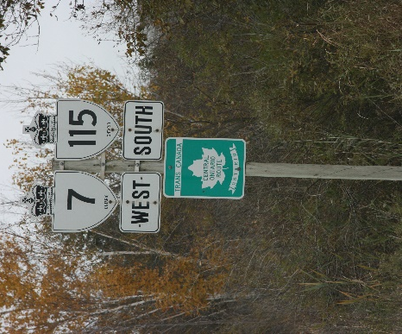
Figure 52: An example of multiple Route Numbers on a single Road Element.
Route Numbers should not have gaps across their span and the names should extend to associated service lanes and ramps.
    - Speed Limit
A linear event identifying the maximum speed limit assigned to a Road Element in kilometers per hour in accordance with Municipal By-Laws or Provincial Law.
    - Street Name Parsed
A non-spatial lookup table containing standardized and abbreviated official and alternate street names. This table also contains the official and alternate parsed components of the street name and must have a street name body but may or may not have a directional prefix/suffix or street type prefix/suffix.

    - Structure
A linear event identifying the location and defined characteristics of structures built to support a road.
      - Structure Type
A description of the road structure.
Table 6: Valid values for Structure Type in the ORN.
Structure Type | Structure Type Description
Bridge | Part of a road supporting the travel of motorized vehicles, built on a raised structure and serving to span an obstacle, river, another road or railway, etc., yet does not have a moveable surface or a building-like cover.  The representation of a Road Structure object corresponds to the stretch of road spanning over the structure. It begins and ends at expansion joints.  When expansion joints are not apparent, the start and end of the Structure are interpreted from the parapet walls of the Bridge structure.
Bridge Covered | Part of a road supporting the travel of motorized vehicles, built on a raised, covered structure and serving to span an obstacle, river, another road or railway, etc.
Bridge Moveable | Part of a road supporting the travel of motorized vehicles, built on a moveable, raised structure and serving to span an obstacle, river another road or railway, etc. The moveable surface allows for the passage of vessels.
Tunnel | An enclosed man-made construction built to carry a transportation element through or below a natural feature or other obstruction.  The representation of a Tunnel Road Structure begins and ends at the beginning and end of the structure.
Dam | Part of a road supporting the travel of motorized vehicles, built across a waterway or floodway to control the flow of water.  The representation of a Dam structure begins and ends at the beginning and end of the structure.

      - Structure Name
Where available, Structure Name such as the ‘Seaway International Bridge’, which crosses the St. Lawrence Seaway at Cornwall, should be populated. Other smaller Structures also have names registered within a government toponymic registry. A Structure Name can be bilingual (English and French) or monolingual (English or French).
    - Toll Point
A point event along a Road Element indicating the presence of a toll point. This table is used to characterize the infrastructure used for collecting a toll charge.
Only toll points located on Road Elements are acquired.
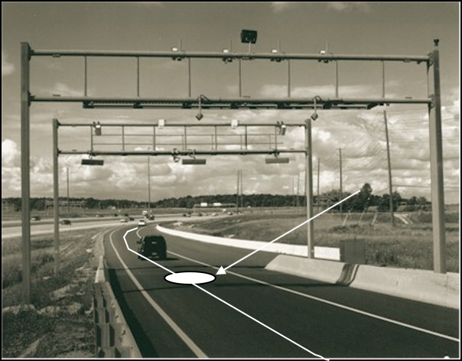
Figure 53: A virtual tollbooth located on Highway 407.

      - Toll Point Type
A description of the toll point.
Table 7: Valid values for Toll Point Type in the ORN.
Toll Point Type | Toll Point Type Description
Hybrid | A tollbooth along a Road Element which is both physical and virtual.
Physical | A construction along or across a Road Element where toll charges can be paid to employees of the organization in charge of collecting the toll or to machines involving electronic methods of payment like credit cards or bank cards.
Virtual | At a virtual point along a Road Element, toll will be charged via automatic registration of the passing vehicle by subscription or invoice.

    - Underpass
A point event on a Road Element identifying the existence of an underpass. An underpass occurs where the Road Element runs underneath a passage accommodating the movement of water, a building, road, rail, pedestrian or wildlife.
- All bridges over roads will have at least one corresponding Underpass point on the segment underneath, but not all Underpasses will have bridges (rail, pedestrian, etc. not captured by the ORN).
- Tunnels will always have an Underpass point (just one, located at the approximate centre of the structure).

      - Underpass Type
A description of the underpass.
Table 8: Valid values for Underpass Type in the ORN.
Underpass Type | Underpass Description
Building | A point at the intersection of a building and the Road Element passing underneath.
Industrial | A point at the intersection of an industrial structure, e.g. utilities and the Road Element passing underneath.
Rail | A point at the intersection of a rail structure and the Road Element passing underneath.
Road | A point at the intersection of a road, e.g. a bridge structure and the Road Element passing underneath.
Walkway | A point at the intersection of a walkway, e.g. a multi-use pathway, skywalk, trail or bike path and the Road Element passing underneath.
Water | A point at the intersection of a water feature and the Road Element passing underneath, e.g. a tunnel.
Wildlife | A point at the intersection of a wildlife corridor and the Road Element passing underneath.

      - Underpasses on Tiered Roads
Underpass points should be placed on segments that represent roads travelling parallel under other roads (tiered). For segments partially within this situation, place the underpass point at the spot the road begins to pass underneath the elevated road.
Examples of tiered roads include: Burlington Road E (and Nikola Tesla Boulevard) in Hamilton, Lake Shore Boulevard (and the Gardiner Expressway) in Toronto and some of the roads around Toronto Pearson International Airport.
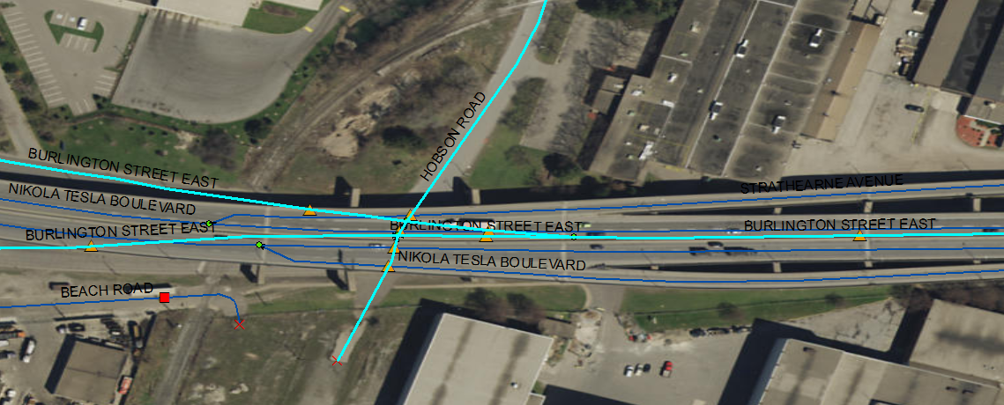
Figure 54: Underpasses are to be placed on tiered roads. In this image, the highlighted segments all have Underpass point events (indicated with the orange triangles). Bridges are not shown for simplicity. Burlington Road E (and Nikola Tesla Boulevard) in Hamilton (-79.796350, 43.256881 Decimal Degrees).

      - Complex Structure Interaction
Busy interchanges may have very complex structure interaction between bridges, tunnels and underpasses.
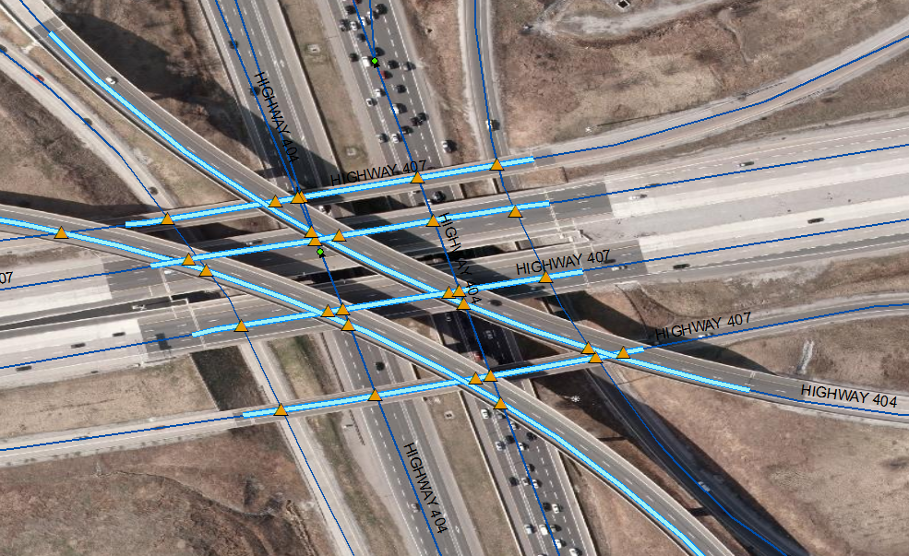
Figure 55: A complex structure interaction and the recommended representation in the ORN. Bridge line events are shown in light blue and Underpass point events as orange triangles. Hwy 404 and Hwy 407 (-79.368412, 43.838950 Decimal Degrees).
Each level of interaction (three levels in Figure 56) maintain different structure attributes. An example to illustrate which segments should receive a bridge, an underpass or both, follows.
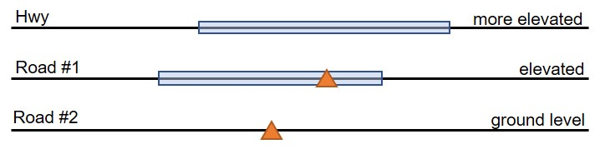
Figure 56: Road Elements at different elevations.

  - Topological Representation (Topology)
The topology of the ORN describes a set of rules and behaviours that are used to model how the Road Elements share coincident geometry, ensuring the data quality of the spatial relationships.
    - Junctions
The ORN is segmented at real-world intersections. Road Elements are bound by a junction on each end, except for cul-de-sacs where there is only one junction. Features that are intended to meet at their end points must share the same junction and therefore have the same coordinate value for the corresponding end points. See 6. Junction.
    - Positional Errors (Digitizing Errors)
The ORN should be free of digitizing errors such as dangles, switchbacks, knots, loops, overshoots and undershoots.
    - Overlap
Road Elements in the ORN must not self-overlap.

- Ferry Connections
The Road Net Element Type Ferry Connection represents the approximate route a ferry travels across water to transport vehicles between two fixed locations in the ORN.
  - Core Content
The following sections define Ferry Connections that are to be captured and represented in the ORN.
    - Mandatory Geometric Representation
The approximate routes of ferryboats designed for transporting vehicles and their passengers across a body of water are to be represented as Ferry Connections in the ORN.
When there is more than one Ferry Connection destination for the same boarding point, each route is to be represented individually (See Figure 57).
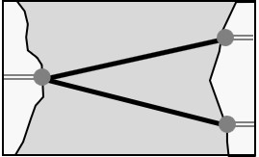
Figure 57: Multiple Ferry Connection destinations for the same boarding point as represented in the ORN.
Ferry Connections cross one another without creating segmentation. Segmentation can never occur in-between Ferry Connections (See Figure 58). Two Junctions always bound a Ferry Connection.
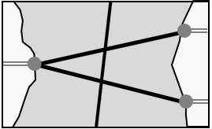
Figure 58: When Ferry Connections intersect, no segmentation is to occur in the ORN.
    - Unauthorized Geometric Representation
Other modes of ferrying, such as rail, air or ‘pedestrian only’ type ferries are not to be represented in the ORN.
  - Positional Representation (Geometry)
Ferry Connections are not subject to the same 10m positional accuracy requirement as Road Elements. The planimetric accuracy value assigned to a Ferry Connection will be in accordance with the highest accuracy value of the Road Elements to which it connects.
    - Route of the Ferryboat
Linear representation begins and ends at boarding points (access ramps).
The route taken by a ferry between two boarding points can be represented by approximation.
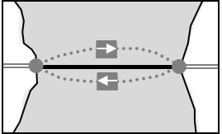
Figure 59: Ferry Connections are represented as an approximation of the average route taken by a ferry in the ORN.
The route taken by a ferry must respect the proper topological relationship of obstacles are present between the boarding points.
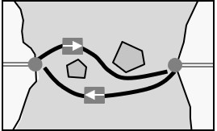
Figure 60: Ferry Connections are to respect the proper topological relationship of obstacles present between boarding points in the ORN.

    - Ferry Route and Ice Bridges
Ferry Route and Winter Road ice crossings are to be represented individually in the ORN. Each representation may be bounded by the same Ferry Junctions but must be offset by a lateral distance of at least 4 metres.
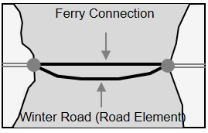
Figure 61: Ferry Connections and Winter Roads may be bound by the same Ferry Junctions but must be offset of at least 4 metres.
    - Ferry Connection Segment Valence
In the real world, there is only one access to a ferry boat. Therefore, each end of a Ferry Connection Segment should connect with only one Road Segment. A Ferry Connection Segment is always bounded by two Junctions.
Ferry Connections cross one another without creating segmentation.
  - Thematic Accuracy (Attributes)
Ferry Connections have fewer allowable events than Road Elements. They include:
- Jurisdiction
- Road Class
- Road Net Element Source
- Route Number
- Route Name
    - Jurisdiction
The Jurisdiction value assigned to a Ferry Connection indicates who has jurisdictional responsibility of the ferry route.
    - Road Class
A Ferry Connection Segment is assigned with the same Road Class value of the two Road Elements that it connects. If the Functional Road Class of the road segments differs, the most prominent class prevails.
    - Road Net Element
The Road Net Element Source indicates the source agency (Municipality, Provincial Ministry, Federal Agency or other organization) that provided the Ferry Connection.
    - Route Number
A Ferry Connection joining two numbered routes must be assigned with the Route Numbers of both Road Elements.
    - Route Name
A Ferry Connection joining a named route must be assigned with the Route Name.

- Virtual Roads
The Road Net Element type Virtual Road represents an address anchor for address information that is collected for dwellings (i.e. cottages) on islands or shorelines that are not accessible by road. Virtual roads exist solely to allow the inclusion of addressing where an actual road is missing.
  - Core Content
The following sections define Virtual Roads that are to be captured and represented in the ORN.
    - Mandatory Geometric Representation
Linear features representing address anchors for Bell 911 address information that is collected for dwellings (i.e. cottages) on islands or shorelines that are not accessibly by road, are to be represented in the ORN.
Virtual Roads in the ORN are not actual driveable roads and may or may not be connected to the main road network.
    - Unauthorized Geometric Representation
Virtual Roads representing shorelines, islands or walkways, etc., should not be captured unless there is addressing or an official name to apply to the segment.
  - Positional Representation (Geometry)
Virtual Roads are used to represent address anchors where physical, driveable roads may not exist or may not connect them to the main road network.

    - Address Anchors on Islands
Address anchors on islands may be represented as (1) following the approximate shoreline of an island; or (2) a straight-line segment which bisects an island. They may also be represented as extensions of the road network crossing over land and water.
Virtual Roads representing the shoreline must have a gap (e.g. 5m) between endpoints. Otherwise pseudo node junctions would result.
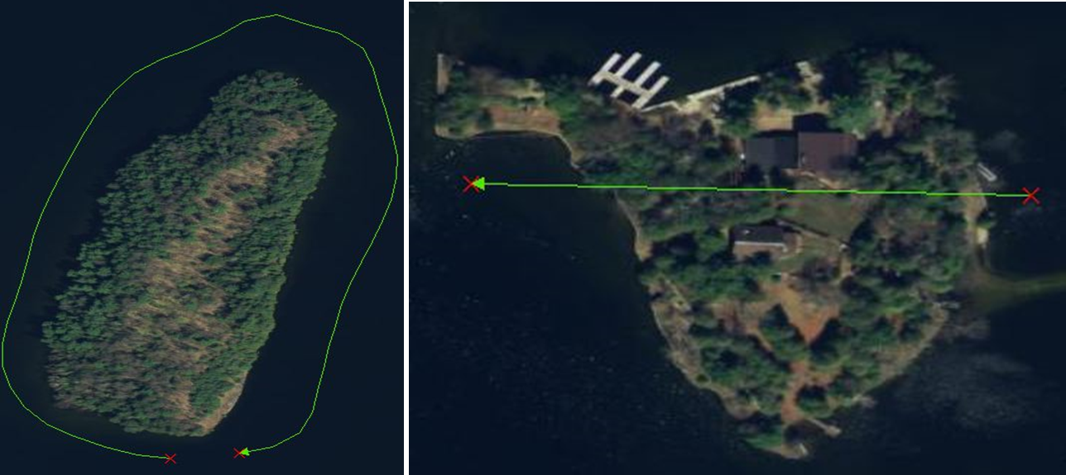
Figure 62: Recommended representation of Virtual Roads in the ORN; (1) as an approximate shoreline that does not connect (left); and (2) a straight-line segment which bisects the island (right).
    - Address Anchors on Walkways
Narrow, non-driveable walkways with addressing are to be represented in the ORN as an approximation of the walkway itself. As an example, the dwellings on the Toronto Islands are serviced by a narrow, hard-top surface but are too narrow to be considered driveable. This network, with addressing, is represented in Figure 63.

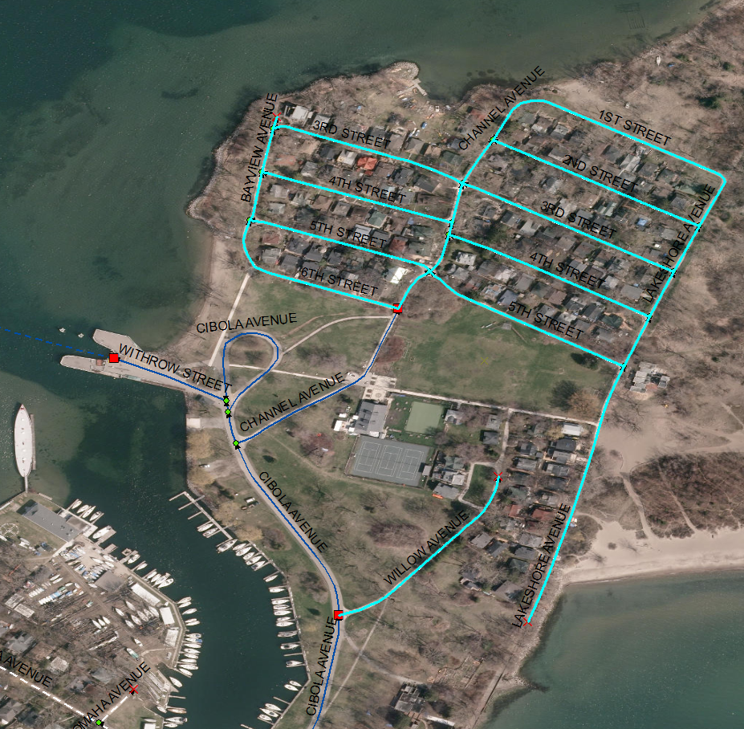
Figure 63: The network of narrow walkways with addressing on the Toronto Islands (-79.354867, 43.632423 Decimal Degrees), are to be represented as Virtual Roads because they are non-driveable (highlighted, above).
  - Thematic Accuracy (Attributes)
Virtual Roads have fewer allowable events than Road Elements. They include:
- Address Info
- Jurisdiction
- Official Name
- Road Net Element Source
    - Address Information
Virtual Roads representing shorelines or islands should not be created unless there is addressing or an official name to apply to the segment.
Names of islands can be used in place of Street Names when provided by the source.
Examples of existing Full Street Names for Virtual Roads:
- 9 MILE LAKE SHORE
- ANSTRUTHER LAKE WATER ACCESS
- BARBER ISLAND
- WYANDOT AVENUE
    - Jurisdiction
The Jurisdiction value assigned to a Virtual Road indicates who has jurisdictional responsibility of the name and/or address of the feature.
    - Official Name
The Official Name of a Virtual Road should match the Full Street Name of its Address Info events.
    - Road Net Element Source
The Road Net Element Source indicates the source agency (Municipality, Provincial Ministry, Federal Agency or other organization) that provided the Virtual Road.

- Junction
Junctions mark the beginning and ending of all Road Net Elements.
  - Core Content
The following sections further define and illustrate examples of real world occurrences for the various Junction types.
    - Mandatory Geometric Representation
The ORN is segmented at real-world intersections or junctions on the ground and Road Net Elements are bound by a junction on each end, except for cul-de-sacs where there is only one junction.
Features that are intended to meet at their end points must share the same junction and therefore have the same coordinate value for the corresponding end points.
      - Junctions at Grade Separated Road Crossings
Where there are grade-separated crossings, the bisecting Road Elements do not share a junction. If a junction is present at the location of the grade separation, it is either connected to the lower set of Road Elements or to the higher but never to both.
  - Positional Accuracy (Geometry)
A Junction is defined at:
- The intersection of three or more roads.
- The intersection of a Road Element and a Ferry Connection.
- The end of a dead-end road.
- The intersection of a Road Element or Ferry Connection with a National, Provincial or Territorial Boundary.
The location of junctions is derived from the linear road network features.

  - Thematic Accuracy (Attributes)
    - Junction Type
The classification of a junction is based on the valency of the junction. The number of Road Elements or Ferry Connections joining at a junction is termed the valency of a junction. For example, a junction that connects a total of two Road Elements is called a two-valent junction.
There are four types of junctions:
- Boundary
- Dead End
- Virtual
- Intersection
      - Boundary
A Boundary junction identifies an intersection of a Road Element or Ferry Connection with a provincial or international boundary. It marks the extent of the ORN dataset.
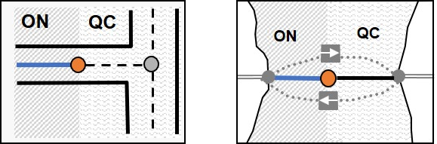
Figure 64: Examples of the placement of a Junction Type: Boundary on the provincial border between Ontario and Quebec, in the ORN (indicated with an orange circle).

      - Dead End Junction
A Dead End junction occurs at the end of a dead-end Road Element: when a single Road Net Element ends without intersecting another Road Net Element.
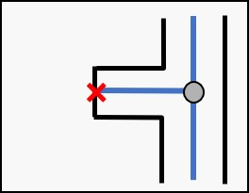
Figure 65: Example of a Junction Type: Dead End in the ORN (indicated by the red X).
At the provincial boundary: When a single Road Net Element ends at a border limit without crossing over into the adjacent province’s dataset indicating the road does not continue further into the next dataset.
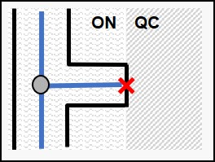
Figure 66: An example of a Junction Type: Dead End used at a provincial boundary to indicate the road does not continue further into the next dataset.
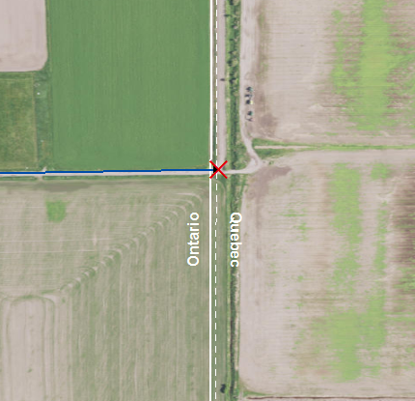
Figure 67: An example in the ORN on the Ontario/Quebec border where a Junction Type: Dead End is used to indicate the road ends at the provincial border (-79.517509, 47.610066 Decimal Degrees).
      - Virtual Junction
A Virtual junction occurs at the intersection of a Road Element and a Ferry Connection. Virtual Junctions are introduced at the boarding point between Road Elements and Ferry Connections. No Junctions are to be introduced when two Ferry Connections cross (See Figure 68).
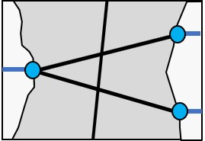
Figure 68: Examples of Junction Type: Virtual (indicated by the blue circles) at the point of intersection between Ferry Connections and Road Elements.

      - Intersection Junction
The most common type of junction that occurs in the ORN is the Intersection junction. Intersection junctions occur at the intersection of three or more Road Elements at the same grade level.
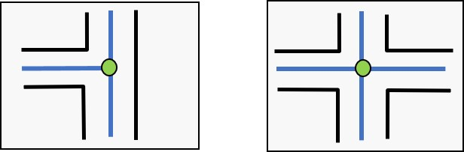
Figure 69: Examples of the most common Junction Type: Intersection in the ORN (indicated by the green circle).
    - Exit Number
When a Road Element portrays a one-way ramp with an exit number, only the Junction marking its point of entrance (in the real world) is assigned with the same Exit Number value. When this ramp can be traveled in both directions, both junctions located at each ends of the Road Net Element are assigned with the same Exit Number value.
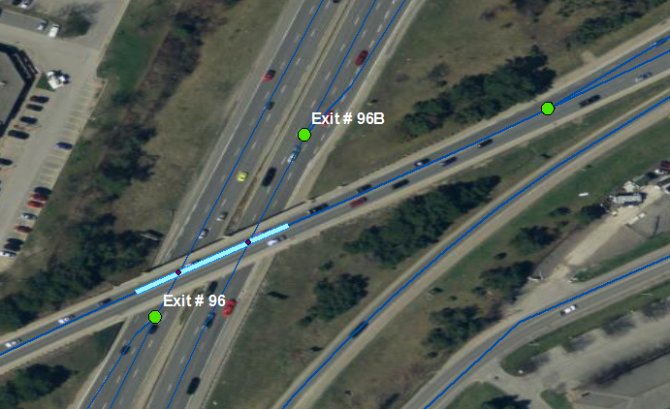
Figure 70: Exit Numbers have been labelled where they exist on Junctions (as indicated by the green circles); HIGHWAY 400 TO DUNLOP STREET WEST in Barrie (-79.710595, 44.380444 Decimal Degrees).
- Address Range
An Address Range is a set of attributes representing the address of the first and last building located along a side of the entire Road Net Element or a portion thereof. Address Info is represented as a linear event in the ORN.
  - Core Content
    - Street Name
The street name recognized by the municipality or naming authority. As a minimal requirement all Address Ranges must have a Street Name.
    - House Number
A house number is the address of a specific location, i.e. a lot or building whether it be public or private, governmental, residential, commercial or industrial.
Unit numbers are not to be considered House Numbers.
    - Address Range
An address range is located along the Left or Right side of a Road Net Element and is formed by a First and Last House Number, a House Number Structure and a Street Name.
      - First-Last and Left-Right Sides
Address ranges are assigned as Right First House Number to Right Last House Number and Left First House Number to Left Last House Number. First-Last and Left-Right are defined in relation with the Road Net Element digitizing direction which adheres to the Lower Left Rule in the ORN.
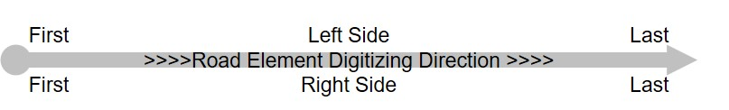
Figure 71: A depiction of (1) the left and right sides; and (2) the first and last numbers as a component of an address range associated with a Road Net Element; in accordance with the digitization direction.
      - House Number Structure
The House Number structure indicates whether the Address Range is exclusively composed of odd or even House Number values or a mix of both. It can also be irregular where the Address Range increment goes up and down.
      - Official Street Name Identifier
An Address Range must be associated with a Street Name that is officially recognised. It can also be associated with as many alternate Street Names as required.
  - Positional Accuracy
    - Street Name Extent
A Street Name change in-between Junctions creates new events on the Road Net Element.
    - Address Range Extent
Address ranges must not overlap on either single or multiple Road Net Elements See examples below.
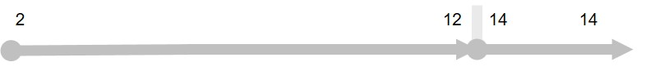
Figure 72: An example of a well-defined address range.
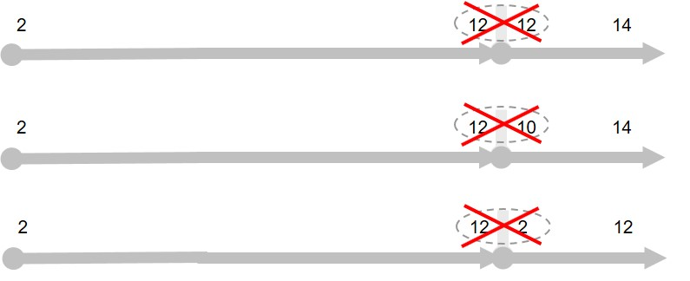
Figure 73: Examples of overlapping address ranges that are not permitted in the ORN.

A Road Net Element can have more than one adjoining address ranges.

Figure 74: An example of well-defined and adjoining address ranges.
    - Street Name Extent
A Street Name or change in-between Junctions creates new events on the Road Net Element. The left and right side are defined in relation to the Road Net Element digitizing direction which must adhere to the Lower Left Rule.
  - Thematic Accuracy
    - Abbreviations for Street Type
Values for Street Type should be spelled out in upper case without the use of abbreviations.
    - Route Names, Route Numbers as Street Names
Unless officially recognized as street names, it is not recommended to insert Route Number and Route Name as Street Name.

- Links to Additional Information
- Access the official Metadata Record by searching Ontario GeoHub for Ontario Road Network, ORN
- ORN Road Net Element on Ontario’s GeoHub (https://geohub.lio.gov.on.ca/datasets/2fd52bccdb77479da0133c86545503f8_0)
- Geospatial Ontario (GEO) (https://www.ontario.ca/page/geospatial-ontario)
- Canadian Federal Government’s GeoGratis: National Road Network (https://open.canada.ca/data/en/dataset/3d282116-e556-400c-9306-ca1a3cada77f)
- GO-ITS 29 Ontario Road Network (https://www.ontario.ca/government/go-its-29-ontario-road-network)
- References
International Organization of Standardization. International Standard (ISO) 14825, Intelligent transport systems – Geographic Data Files (GDF).
Natural Resources Canada, Geomatics Canada Centre for Topographic Information. “National Road Network Guide to Best Practices for Acquisition, Edition 2.0”. 2009.
Transportation Association of Canada (TAC). “Geometric Design Guide for Canadian Roads”. 2017.

- Appendix A: Merging Angles
The logic regarding the centreline merging angles is based on actual driving habits and is summarized as follows:
One must take normal road speeds and reasonable driving requirements into consideration when determining what constitutes a minimum deflection angle.
The following assumptions have been used to establish what should constitute a minimal angle:
- It takes approximately two to three seconds to safely move a vehicle from one lane into another.
- It results in a deflection of approximately 4 metres.
From the following table, one can see that the minimum distance required to perform that manoeuvre increases with speed.
Table 9: Minimum distance required for changing lanes in 2 seconds at 50 and 100 km/h.
Speed (km/hr) | Distance (m) required for changing lanes in 2 seconds | Distance (m) required for changing lanes in 3 seconds
50 | 28 | 42
100 | 56 | 83

At the local street level (50 km/h) twenty-eight to forty-two metres are needed while fifty-six to eighty-three metres are required at highway speeds (100 km/h).
Based on these premises it can be determined that a deflection angle of five to eight degrees would suit local street speeds (50 km/h) while an angle of three to four degrees would suit highway speeds (100 km/h).
It is also important to note that highway on-ramps tend to be longer than off-ramps. Presumably this lane is designed to consider the length of time required to accelerate and allow for safely merging with highway traffic.
For example, when moving from a 1-lane through road to a diverging 1-lane ramp, the following representation could be used:
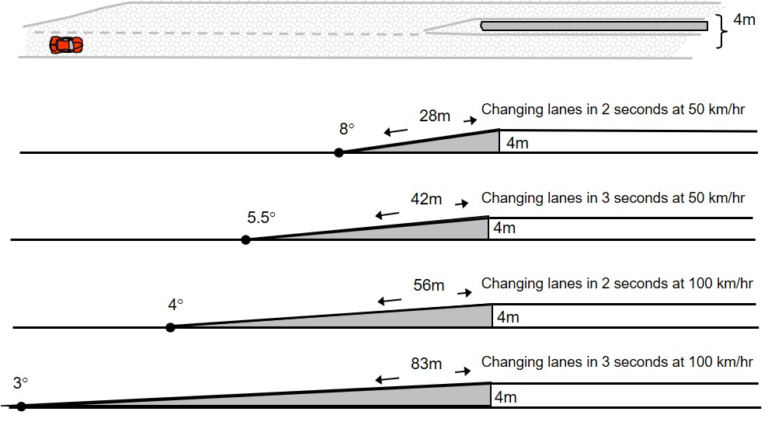
Figure 75: Representation of merging angles with changing speed.

When moving from four lanes to two lanes divided by a median (>250m) the same general logic can be applied.
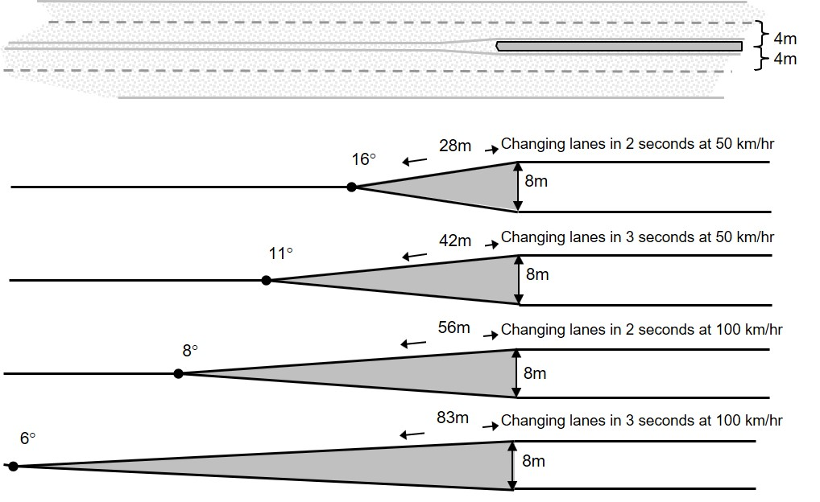
Figure 76: Representation of merging angles when moving from four lanes to two lanes divided by a median (>250 m), with changing speed.

As a minimal requirement, merging angles should never exceed ninety degrees. An angle of sixty degrees is more reasonable and the recommended practice for capturing merging angles in the ORN.
Figure 77: Merging angles should never exceed 90º. An angle of 60º is more reasonable and the recommended practice for capturing merging angles in the ORN.

- Photo Examples
  - Blocked Passages
See 3.3.4 Blocked Passage Type
    - Examples of Permanently Fixed Blocked Passages
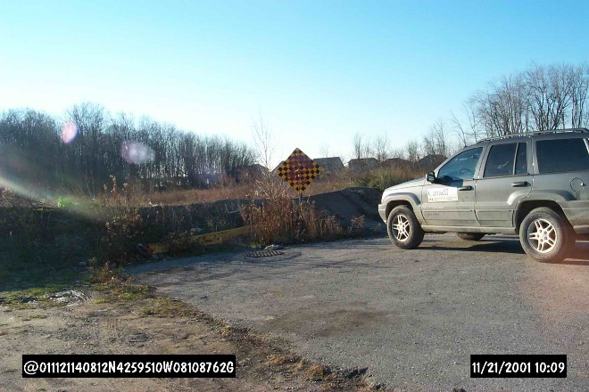
Figure 78: This berm (pictured) would require heavy equipment to remove and should therefore be represented as a Permanently Fixed Blocked Passage in the ORN.
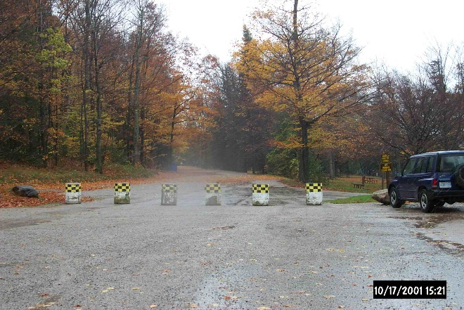
Figure 79: Concrete blocks (pictured) are an example of a Permanently Fixed Blocked Passage in the ORN.

    - Example of a Removable Blocked Passage
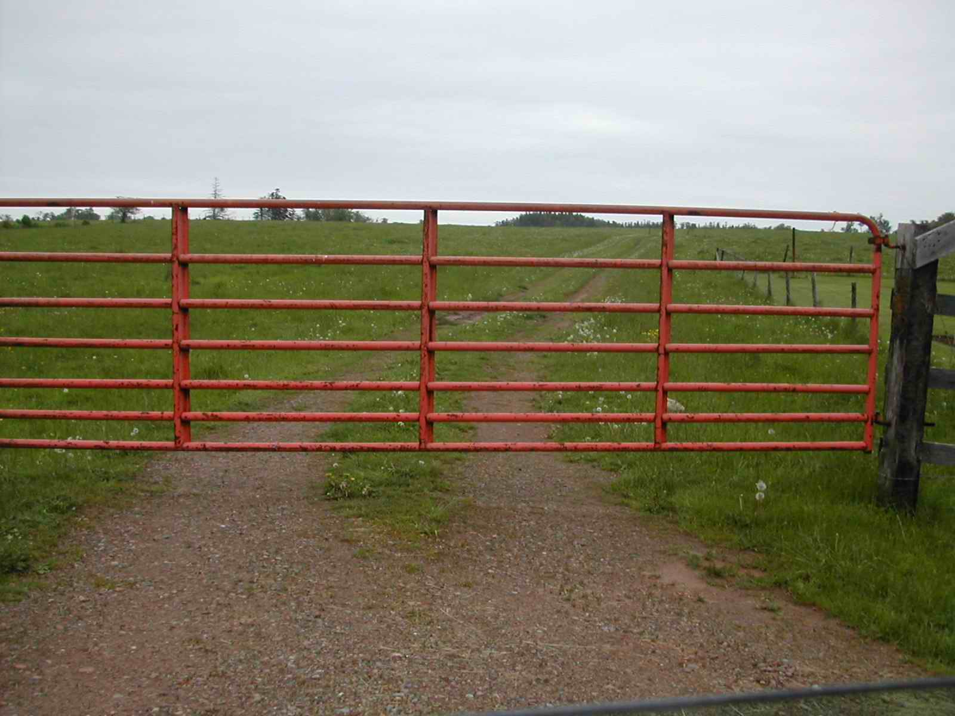
Figure 80: Human-made obstacles placed across a roadway designed to easily allow further access when so desired (such as this gate) are to be represented as Removable Blocked Passages in the ORN.

  - Road Surface – Pavement Status
See 3.3.11 Road Surface.
    - Examples of Paved Road Surfaces
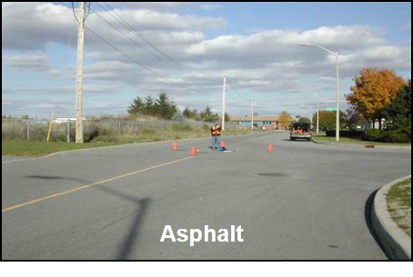
Figure 81: Asphalt is an example of a Paved and Flexible Road Surface in the ORN.

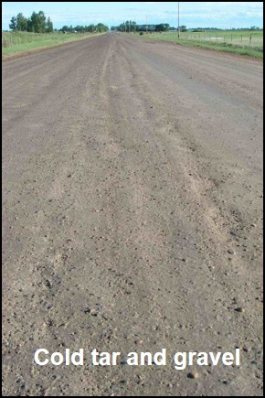
Figure 82: Cold tar and gravel mixture is an example of a Paved and Flexible Road Surface in the ORN.

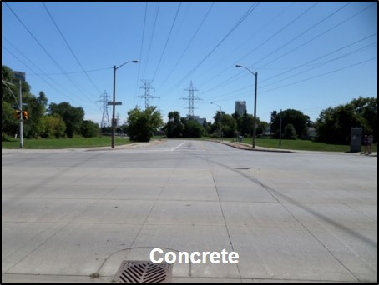
Figure 83: Concrete is an example of a Paved and Rigid Road Surface in the ORN.

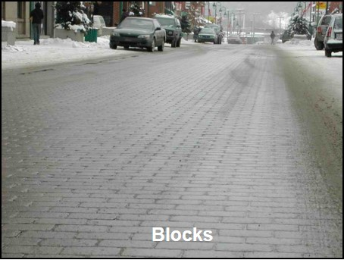
Figure 84: Blocks are an example of a Paved and Block Road Surface in the ORN.

    - Examples of Unpaved Road Surfaces
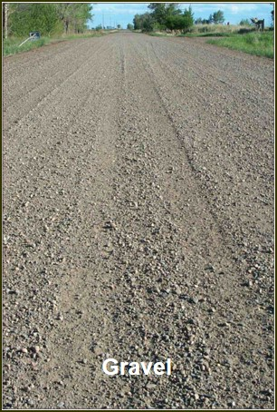
Figure 85: An example of an Unpaved and Gravel Road Surface in the ORN.

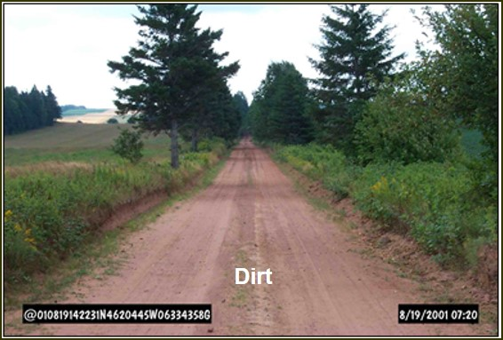
Figure 86: An example of an Unpaved and Dirt Road Surface in the ORN.

  - Structure Type
See 3.3.16 Structure.
    - Examples of Road Structure Type
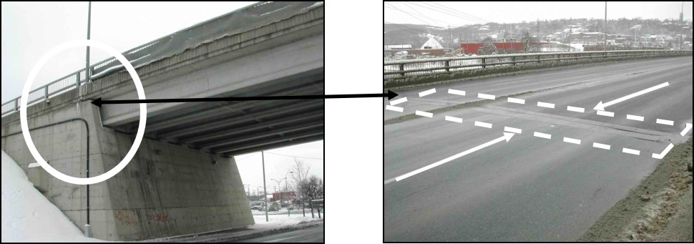
Figure 87: The representation of a Road Structure object corresponds to the stretch of road spanning over the structure. It begins and ends at the expansion joints as indicated above.

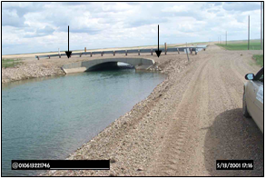
Figure 88: When expansion joints are not apparent, the start and end of a Structure are interpreted from the parapet walls of the Bridge structure, as indicated above.
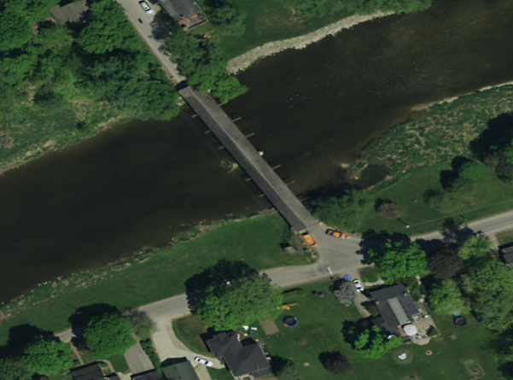
Figure 89: An example of a Road Structure Type: Bridge Covered.
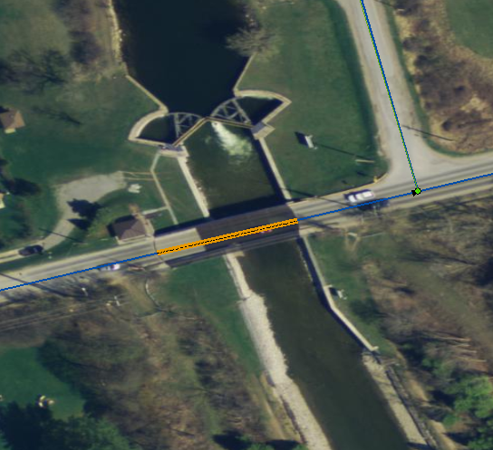
Figure 90: An example of a Road Structure Type: Bridge Moveable.
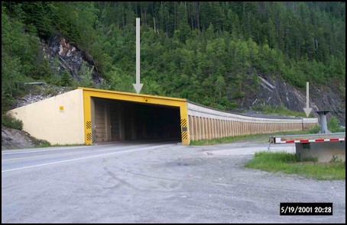
Figure 91: An example of a Road Structure: Tunnel.
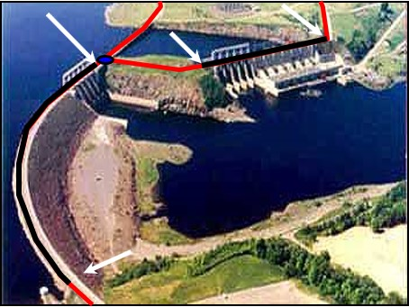
Figure 92: An example of a Road Structure: Dam. The representation of a Dam structure begins and ends at the beginning and end of the structure, as indicated above in black.

  - Underpasses
See 3.3.18 Underpass.
    - Examples of Underpass Type.
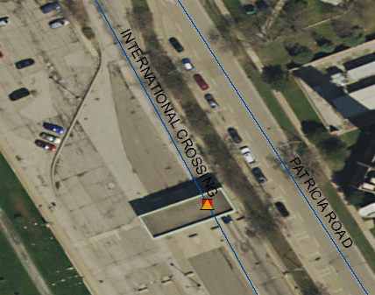
Figure 93: An example of an Underpass Type Building (-83.065512, 42.303375 Decimal Degrees).

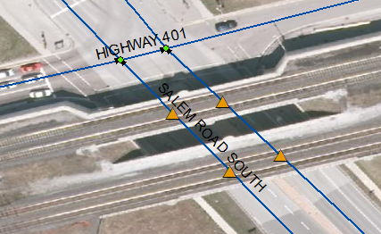
Figure 94: An example of an Underpass Type: Rail (-79.011522, 43.854887 Decimal Degrees).
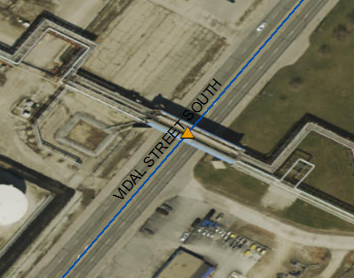
Figure 95: An example of an Underpass Type: Industrial (-82.423341, 42.938857 Decimal Degrees).
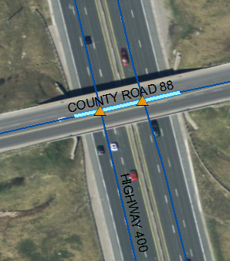
Figure 96: An example of an Underpass Type: Road (-79.630743, 44.099408 Decimal Degrees)

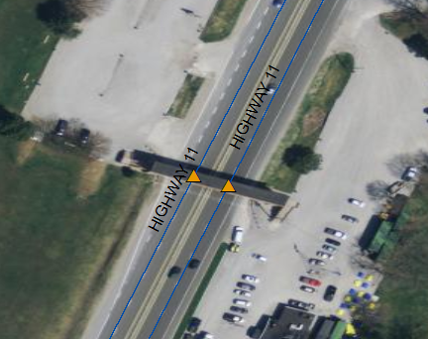
Figure 97: An example of an Underpass Type: Walkway (-79.399165, 44.694453 Decimal Degrees).

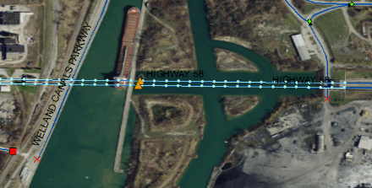
Figure 98: An example of an Underpass Type: Water (-79.194157, 43.115424 Decimal Degrees).

Version 2526.1

Rights-of-way 20 m in width applicable to retrofit conditions only.
Wider rights-of-way are often required to accommodate other facilities such as utilities, noise mitigation implications, bikeways and landscaping for new streets, the immediate provision of wider rights-of-way may be considered to accommodate such facilities.

